|  |  |
| --- | --- |
|  | **MINISTRY OF EDUCATION AND TRAINING** |
| **FPT UNIVERSITY** | |
| Capstone Project Document | |
| **Application to identify plants and trees in school grounds** | |

|  |  |
| --- | --- |
| **GFA31SE31** | |
| **Group Members** | Nguyen Thanh Tung– Team Leader – SE140765  Le Minh Khoi – Team Member – SE140729  Nguyen Van Sang – Team Member – SE140439  Phan Hoang Chien – Team Member – SE140586 |
| **Supervisor** | Mr. Doan Nguyen Thanh Hoa |
| **Capstone Project code** | FA23SE122 |

- Ho Chi Minh, Nov 2023 –

**Table of Contents**

Acknowledgement 10

Definition and Acronyms 10

I. Project Introduction 11

1. Overview 11

1.1 Project information 11

1.2 Project Team 11

a. Supervisor 11

b. Team Members 11

2. Product Background 12

3. Existing Systems 12

4. Software Product Vision 12

5. Project Scope & Limitations 12

**5.1. Major features** 12

**5.2. Limitations & Exclusions** 13

II. Project Management Plan 13

1. Overview 13

**1.1 Scope & Estimation** 13

**1.2 Project Objectives** 16

**1.3 Project Risks** 16

2. Management Approach: 17

**2.1 Project Process:** 17

**2.2 Quality Management** 17

3. Project Deliverables 18

4. Responsibility Assignments 19

**4.1 Teams & Structures** 19

**4.2 Roles & Responsibility** 20

5. Project Communication 21

**5.1 Communication Plan** 21

**5.2 External Interface** 21

6. Configuration Management 22

**6.1 Document Management** 22

**6.2 Source Code Management** 22

**6.3 Tools & Infrastructure** 22

III. Software Requirements Specification 23

1. Product Overview 23

**1.1 Manager Requirements** 23

**1.2 Admin Requirements** 23

**1.3 User Requirements** 23

**2.1 Use case diagram** 24

**2.2 List of use case with description** 25

3. Functional Requirements: 31

4. Non-Functional Requirements 38

**4.1 External Interfaces** 38

4.1.1 User Interfaces 38

4.1.2 Communications Interfaces 38

**4.2 Quality Attributes** 38

4.2.1 Usability 38

4.2.2 Maintenance 38

4.2.3 Security 38

4.2.4 Reliability 38

4.2.4 Supportability 38

5. Requirement Appendix 38

5. Requirement Appendix 38

**5.1 Business Rules** 38

**5.2 Application Messages List** 40

IV. Software Design Description 40

1. System Design 40

1.1 System Architecture 41

1.2 Package Diagram 42

1.2.1 Mobile Package Diagram 42

1.2.2 Backend Package Diagram 43

2. Database Design 45

**2.1. Entity Relationship Diagram** 45

**2.2. Database Diagram** 45

**2.3. Data Dictionary** 46

2.3.1. Category 46

2.3.2. Class 46

2.3.3. ClassLabel 47

2.3.4. Exam 47

2.3.5. Image 48

2.3.6. Label 48

2.3.7. Manager 48

2.3.8. Plant 49

2.3.9. Plant Category 50

2.3.10. Question 50

2.3.11. QuestionExam 51

2.3.12. Report 51

2.3.13. Student 52

2.3.14. StudentClass 53

2.3.15. HangFire.AggregatedCounter 54

2.3.16. HangFire.Counter 54

2.3.17. HangFire.Hash 55

2.3.18. HangFire.Job 55

2.3.19. HangFire.JobParameter 56

2.3.20. HangFire.JobQueue 56

2.3.21. HangFire.List 56

2.3.22. HangFire.Schema 57

2.3.23. HangFire.Server 57

2.3.24. HangFire.Set 58

2.3.24. HangFire.State 58

3. Detailed Design 59

**3.1 *Detect Plant*** 59

*3.1.1 Class Diagram* 59

3.1.2 Class Specification 60

3.1.3  *Sequence Diagram* 61

**3.2 Class Management** 62

*3.2.1 Class Diagram* 62

3.2.2 Class Specification 63

3.2.3 Sequence Diagram 64

**3.3 User Management** 65

*3.3.1 Class Diagram* 65

3.3.2 Class Specification 66

3.3.3  *Sequence Diagram* 67

**3.4 Label Management** 68

*3.4.1 Class Diagram* 68

3.4.2 Class Specification 69

3.4.3  *Sequence Diagram* 70

**3.5 Report Management** 71

*3.5.1 Class Diagram* 71

3.5.2 Class Specification 72

3.5.3  *Sequence Diagram* 73

V. Software Testing Documentation 73

1. Scope of Testing 73

2. Test Strategy 74

**2.1 Testing Types** 74

**2.2 Test Levels** 74

3. Test Plan 74

**3.1 Human Resources** 74

**3.2 Test Milestones** 74

4. Test Cases and Test Reports 75

VI. Release Package & User GuidesReport5_Test Case Document 75

1. Deliverable Package 75

2.Installation Guides 75

**2.1 System Requirements** 75

**2.2 Installation Instruction** 76

2.2.1 Environment setup 76

2.2.2 Run Backend Server 76

2.2.3 Run Mobile application. 78

3. User Manual 79

**3.1. Overview** 79

**3.2 User search information plant** 79

**3.3 User join class** 87

**3.4 User join game** 95

**3.5 Admin manage class and report** 99

**3.6 Admin manage plan and label** 102

**3.7 Admin manage quiz game** 105

**3.8 Manager class** 106

**3.8.1 Manager reports** 111

**3.8.2 Manager model** 112

**LIST OF TABLES**

Table 1. Definition and Acronyms 10

Table 2. Supervisor 11

Table 3. Team Members 11

Table 4. Scope & Estimation 15

Table 5. Project Objectives 16

Table 6. Project Risks 16

Table 7. Training Plan 18

Table 8. Project Deliverables 19

Table 9. Roles & Responsibilities 20

Table 10. Communication Plan 21

Table 11. FU Contacts 21

Table 12. Use Case List 30

Table 14. Business Rule 33

Table 15.  System Architecture Diagram Description 36

Table 16. Mobile Package Diagram Description36

Table 17. Backend Package Diagram Description38

Table 18.  Category Table39

Table 19. Class Table41

Table 20. Class Label Table42

Table 21. Exam Table42

Table 22.  Image Table43

Table 23. Label Table44

Table 24. Manager Table45

Table 25. Plant Table46

Table 26. PlanCategory Table46

Table 27. Question Table47

Table 28. QuestionExam Table47

Table 29. Report Tablee 48

Table 30. Student Table50

Table 31. Student Class Table52

Table 32. HangFire.AggregatedCounter Table52

Table 33. HangFire.Counter Table53

Table 34. Hash Table53

Table 35. Job Table54

Table 36. JobPaarameter Table54

Table 37. JobQueue Table55

Table 38. List Table55

Table 39. Schema Table55

Table 40. Server Table56

Table 41. Set Table57

Table 42. State Table57

Table 43. Detect Plant Class Specification61

Table 44. Class Management Specification64

Table 45. User Management Class Specification69

Table 46. Label Management Class Specification72

Table 47. Report Management Class Specification75

Table 48. Human Resources76

Table 49. Test Milestones 77

Table 50. Deliverable Package77

Table 51. System Requirements 78

**LIST OF FIGURES**

Figure 1. Team & Structures 19

Figure 2. Use Case Diagram 25

Figure 3. Create class31

Figure 4. Approve/Reject class32

Figure 5. Join class32

Figure 6. Class detail33

Figure 7. Plant detection34

Figure 8. Send report35

Figure 9. Approve/Deny report36

Figure 10.1 Reject report36

Figure 10.2 Approve report 37

Figure 11. System Architecture Diagram41

Figure 12. Mobile Package Diagram42

Figure 13. Backend Package Diagram43

Figure 14. Entity Relationship Diagram (ERD)45

Figure 15. Database Diagram45

Figure 16. Detect plant60

Figure 17. Detect plant Sequence Diagram62

Figure 18. Class Management64

Figure 19. Class Management Sequence Diagram65

Figure 20. Nearby Feature Sequence Diagram 66

Figure 21. User Management Class Diagram. 67

Figure 22. User Management Sequence Diagram69

Figure 23. Label Management Class Diagram. 70

Figure 24. Label Management Sequence Diagram. 72

Figure 25. Report Management Class Diagram73

Figure 26. Report Management Sequence Diagram. 75

Figure 27. Edit configuration files.. 79

Figure 28. Load project.. 79

Figure 29. Run application.80

Figure 30. Application runs successfully 80

# Acknowledgement

First, we would like to thank Mr. Doan Nguyen Thanh Hoa for agreeing to be our guide for this project. During the project, his input, support, sincerity, and passion helped us complete this project to the best of our ability.

Furthermore, we would like to express our gratitude to the other lecturers: Mr. Hoang, Mr. Sang, Ms. Van, and Mr. Nguyen; and friends who provided us with valuable advice and suggestions for this project.

Finally, we would like to express our gratitude to all members of this project team for their tireless efforts, excitement, and hard work in contributing to this project.

# Definition and Acronyms

|  |  |
| --- | --- |
| **Acronym** | **Definition** |
| BR | Business Rule |
| ERD | Entity Relationship Diagram |
| GUI | Graphical User Interface |
| SDD | Software Design Description |
| SRS | Software Requirement Specification |
| API | Application Program Interface |

*Table 1. Definition and Acronyms*

# I. Project Introduction

## 1. Overview

### 1.1 Project information

* Project name: Application to identify plants and trees in school grounds
* Project code: FA23SE122
* Group code: GFA23SE31
* Software type: Web application, Mobile application

### 1.2 Project Team

#### a. Supervisor

|  |  |  |  |
| --- | --- | --- | --- |
| **Full Name** | **Email** | **Phone Number** | **Title** |
| Doan Nguyen Thanh Hoa | [Hoadnt@fe.edu.vn](mailto:Hoadnt@fe.edu.vn) |  | Mr. |

*Table 2. Supervisor*

#### b. Team Members

|  |  |  |  |
| --- | --- | --- | --- |
| **Full Name** | **Email** | **Mobile** | **Role** |
| Nguyen Thanh Tung | [tungntse140765@fpt.edu.vn](mailto:tungntse140765@fpt.edu.vn) | 0969 499 813 | Leader |
| Le Minh Khoi | [khoilmse140729@fpt.edu.vn](mailto:khoilmse140729@fpt.edu.vn) | 0909 418 120 | Member |
| Phan Hoang Chien | [chienphse140586@fpt.edu.vn](mailto:chienphse140586@fpt.edu.vn) | 0964 904 917 | Member |
| Nguyen Van Sang | [sangnvse140439@fpt.edu.vn](mailto:sangnvse140439@fpt.edu.vn) | 0964 077 946 | Member |

*Table 3. Team Members*

## 2. Product Background

Nowadays AI is developing very strongly, having an application that is friendly and reliable for users, especially students who are in the age of learning and curious about everything around them. Therefore, helping young people access and understand more about AI is extremely important. Today we are honored to introduce our application, designed to help students understand more about AI, and our application can also help students understand more about trees.

The main goal of our application is to help students identify trees in the schoolyard, helping them better understand how AI works. The application also has the function of helping students provide datasets through which students can contribute to building AI models.

In short, our application was created to help students easily access AI and understand more about the plants around them. With a friendly, easy-to-use interface, it can identify 10-20 different types of plants. This application will be of great help to students in the future.

## 3. Existing Systems

Currently in Vietnam, AI is quite new and is still reaching young people. Our app focuses on students and young people, people who are curious and learning about AI.

## 4. Software Product Vision

Aspires to accompany young people and students, helping them easily identify and understand more about plants. Our software product vision focuses on providing user-friendly features and accurate sources of information that have been vetted by experts. We envision a future where AI becomes even more powerful, becoming an integral part and connecting people through our app's knowledge and information.

## 5. Project Scope & Limitations

### **5.1. Major features**

We help users identify plants they don't know, user-friendly interface, a pre-designed camera in the app to help them more conveniently use the app, and also have features such as Sharing and posting images so users can interact with other users.

Users can contribute data to build applications through the manager's approval.

For application administrators, it makes managing data and information easier. They can easily manage tree information, thereby easily collecting information on many different tree types, increasing dataset capacity, and upgrading existing data in the application.

Our application prioritizes accuracy when identifying trees, and protecting user information, and especially will use the information users provide to develop the application completely free of charge.

### **5.2. Limitations & Exclusions**

Although the goal of the application is to identify trees with high accuracy, the application's current dataset is still very limited, so the application's accuracy is only at a temporary level. Our application cannot accurately identify certain situations such as there are many mixed scenes, can only identify photos taken from real objects, the number of trees is limited, and still depends a lot on the device user.

The functionality of the application is based on an Android or iOS device with a stable Internet connection and normal operation of the user's device. We cannot be responsible for any interruptions, delays, or limitations due to network connection problems or technical problems experienced by users' devices.

# II. Project Management Plan

## 1. Overview

### **1.1 Scope & Estimation**

|  |  |  |  |
| --- | --- | --- | --- |
| **No** | **WBS Item** | **Complexity** | **Est. Effort**  **(man-days)** |
| **1** | **User Login** | Simple | 3 |
| **2** | **User Authorization** | Simple | 4 |
| **3** | **Reset Password** | Simple | 2 |
| **4** | **Manage User Profile** |  |  |
| 4.1 | View User Profile | Simple | 2 |
| 4.2 | Update User Profile | Simple | 2 |
| **5** | **Home Page** | Simple | 4 |
| **6** | **Manage Class** |  |  |
| 6.1 | View List Classes | Simple | 3 |
| 6.2 | View List Users | Simple | 2 |
| **7** | **Class Detail** |  |  |
| 7.1 | Change class status | Simple | 3 |
| 7.2 | Update AI model | Complex | 8 |
| 7.3 | Remove users | Simple | 3 |
| **8** | **Report** |  |  |
| 8.1 | View List Reports | Simple | 3 |
| 8.2 | View List Reports by class | Simple | 2 |
| 8.3 | View List Reports by label | Simple | 2 |
| 8.4 | View Image in Report | Simple | 3 |
| 8.5 | User send Report | Simple | 3 |
| 8.6 | Search Report | Simple | 2 |
| 8.7 | Sort Report | Simple | 2 |
| 8.8 | Censorship Report | Simple | 2 |
| **9** | **Plant Resource** |  |  |
| 9.1 | Find plants | Simple | 4 |
| 9.2 | Search plants | Simple | 4 |
| 9.3 | Sort plants | Simple | 4 |
| 9.4 | Create plants | Simple | 4 |
| 9.5 | Update plants | Simple | 4 |
| 9.6 | Delete plants | Simple | 4 |
| 9.7 | View plants detail | Simple | 5 |
| **10** | **Build AI model** | Complex | 15 |
| **11** | **Mini game** |  |  |
| 11.1 | Create mini game questions | Simple | 3 |
| 11.2 | Update mini game questions | Simple | 3 |
| 11.3 | Join game | Simple | 3 |
| 11.4 | Search mini game questions | Simple | 3 |
| **12** | **Send Request** | Simple | 3 |
| **13** | **Take photo** | Simple | 3 |
| **14** | **Manage Label** |  |  |
| 14.1 | View list label | Simple | 3 |
| 14.2 | Add label | Simple | 3 |
| 14.3 | Search label | Simple | 3 |
| 14.4 | Update label | Simple | 3 |
| 14.5 | Delete label | Simple | 3 |
| 14.6 | Sort label | Simple | 3 |
| **15** | **Upload photo from library** | Simple | 4 |
| **16** | **Crop photo** | Simple | 4 |
| **17** | **Notification** | Simple | 4 |
| **18** | **Design UI** | Complex | 10 |
| ***Total Estimated Effort (man-days)*** | | | ***170*** |

*Table 4. Scope & Estimation*

### **1.2 Project Objectives**

|  |  |  |  |  |
| --- | --- | --- | --- | --- |
| **#** | **Testing Stage** | **No. of Defects** | **% of Defect** | **Notes** |
| 1 | Reviewing | 10 | 12.5% |  |
| 2 | Unit Test | 45 | 56.25% |  |
| 3 | Integration Test | 10 | 12.5% |  |
| 4 | System Test | 8 | 10% |  |
| 5 | Acceptance Test | 7 | 8.75% |  |
| **Total** | | 80 | 100% |  |

*Table 5. Project Objectives*

* Milestone Timeliness (%): Each milestone should be completed within 10% of the allocated time.
* Allocated Effort (man-days):
  + Requirements gathering and analysis: 30 man-days
  + Design: 35 man-days
  + Coding and testing: 145 man-days
  + Project management and maintenance: 30 man-days

### **1.3 Project Risks**

|  |  |  |  |  |
| --- | --- | --- | --- | --- |
| **#** | **Risk Description** | **Impact** | **Possibility** | **Response Plans** |
| 1 | Data quality | Low accuracy of the AI application | High | Collect data from multiple sources to ensure diversity and accuracy, and implement data cleaning and validation processes |
| 2 | Technical difficulties | Delayed project timeline and increased costs | Medium | Conduct thorough testing and quality assurance, and have contingency plans in place for technical issues |
| 3 | Lack of student participation | Insufficient data for training and limited student engagement | Low | Encourage and incentivize student participation through gamification and rewards, and provide clear communication on the importance of their contributions |
| 4 | Ethical concerns | Negative impact on the environment or privacy violations | Low | Conduct ethical reviews and assessments, and ensure compliance with relevant laws and regulations |
| 5 | Limited resources | Inadequate funding or staffing | Medium | Prioritize tasks and allocate resources efficiently, and seek additional funding or support if necessary |

*Table 6. Project Risks*

## 2. Management Approach:

### **2.1 Project Process:**

This project is developed under the Scrum framework of Agile methodology. We chose this process model for the following reasons:

* Improved Quality: The Agile Scrum process incorporates regular testing and reviews, ensuring that the AI models are thoroughly validated at each step. This contributes to the overall quality and reliability of the final product.
* Adaptation and Continuous Improvement:
  + Flexibility: Agile Scrum encourages adaptability. Be open to adjusting processes based on the team's dynamics and feedback from your mentor.
  + Continuous Learning: Use retrospectives to learn from each sprint and continuously improve team collaboration and project outcomes.
* Continuous Feedback Loop: AI projects benefit from continuous feedback loops to refine algorithms and models. Agile Scrum's regular sprint reviews and daily stand-up meetings provide opportunities for stakeholders to provide input, ensuring that the project aligns with expectations.
* Dynamic AI Development: Harnessing Agile Scrum for Quality, Adaptation, and Continuous Improvement with New Datasets.

### **2.2 Quality Management**

In this project, to improve the project’s quality, we use the following approach:

* API:
  + Name the API Route that maps the entity in the system.
  + Each API response must return the following information:
* Status response: fail, success, detail description.
* Paging: page number and size
* HTTP methods: GET, POST, PUT, PATCH, DELETE.
* Coding:
* Set a clear and concise variable.
* Adding enough comments to avoid making the code confusing.
* Unit Testing: Each team member is responsible for validating individual components and functions of the product.
* Integration Testing: After completing the unit testing, the team make a client and server collaboration to assess the interaction and cooperation between different part of applications, spanning from client-side to server-side.
* System Testing: The team member evaluates the complete product through all test case, considering its functionality and behavior within a simulated environment.

2.3 Training Plan

|  |  |  |  |
| --- | --- | --- | --- |
| Training Area | Participants | When, Duration | Waiver Criteria |
| .NET | Nguyen Thanh Tung | 20/10-23/10 | Mandatory |
| Flutter, AI | Nguyen Van Sang | 20/10-23/10 | Mandatory |
| Flutter | Phan Hoang Chien | 20/10-23/10 | Mandatory |
| ReactJS | Le Minh Khoi | 20/10-23/10 | Mandatory |

*Table 7. Training Plan*

## 3. Project Deliverables

|  |  |  |  |
| --- | --- | --- | --- |
| Sprint # | Sprint objective | Duration | Deliverable |
| 1 | Project Plan Document, SRS Document | 14 days | Project Planning, Software Requirement |
| 2 | Design Document | 14 days | Architecture Design, Basic Design, Detail Design and Database Design |
| 3 | Authentication Module, User Module, Role Module, Manager Module | 14 days | Code & System test cases |
| 4 | Class Module, Plant Module, Label Module | 14 days | Code & System test cases |
| 5 | Module, AI bot Module, Report Module,  Game Module | 14 days | Code & System test cases |
| 6 | Question Module, Notification Module, Final Code Package | 14 days | Code & System test cases |
| 7 | Test Reports, User Guide Documents,  Final Project Package | 14 days | Code & System test cases,  User manual guides,  Final code, documents, and User manual guides |

*Table 8. Project Deliverables*

## 4. Responsibility Assignments

### **4.1 Teams & Structures**

**DEVELOPMENT TEAM**

Nguyen Thanh Tung Nguyen Van Sang

Phan Hoang Chien

Le Minh Khoi

**PRODUCT OWNER SCUM MASTER**

Doan Nguyen Thanh Hoa

*Figure 1. Team & Structures*

### **4.2 Roles & Responsibility**

|  |  |
| --- | --- |
| **Role** | **Responsibility** |
| Product Owner (Đoàn Nguyễn Thành Hòa) | * Specify user requirements. * Control the development process. * Review products and documents. |
| Scrum Master  (Đoàn Nguyễn Thành Hòa) | * Managing process. * Track backlog. * Designing database. * Clarifying requirements. * Quality management. * Arrange a meeting. |
| Team Member  (Nguyễn Thanh Tùng,  Nguyễn Văn Sáng,  Lê Minh Khôi,  Phan Hoàng Chiến) | * Prepare documents. * Designing database. * Clarifying requirements. * Prepare documents. * Coding. * Create a test plan. * Testing. * GUI design. * Support other team members. |

*Table 9. Roles & Responsibilities*

## 5. Project Communication

### **5.1 Communication Plan**

|  |  |  |  |  |
| --- | --- | --- | --- | --- |
| **Communication Item** | **Who/ Target** | **Purpose** | **When, Frequency** | **Type, Tool, Method(s)** |
| Working with advisor | Supervisor and team members | * Discuss project requirements * Report issues and give feedback * Review documentations * Validate functionalities * Evaluate progress | Once per week | Face to face, Google Meet, Messenger |
| Working in team | Team members | * Support each other to solve issues * Report task to leader * Expresss any ideas | Everyday | Face to face, Google Meet, Messenger |

*Table 10. Communication Plan*

### **5.2 External Interface**

FU Contacts

|  |  |  |  |
| --- | --- | --- | --- |
| **Function** | **Contact Person**  **(Name, position)** | **Contact address.**  **(Email, telephone)** | **Responsibility** |
| Advisor | Doan Nguyen Thanh Hoa | hoadnt@fpt.edu.vn | * Provide document template * Give instruction to project team * Review deliverables * Supervise project status |

*Table 11. FU Contacts*

## 6. Configuration Management

### **6.1 Document Management**

* Identify the key project documents: Start by identifying the key project documents that will need to be managed.
* Establish a version control system: Once you have identified the key project documents, establish a version control system to manage changes to these documents.
* Define a naming convention: Establish a naming convention for your project documents that makes it easy to identify the latest version of each document. For example, you could use a naming convention like "DocumentName_v1.0" to indicate the first version of a document.
* Assign ownership and access rights: Assign ownership of each document to a specific team member and define access rights for each document based on team roles and responsibilities.
* Establish a review and approval process: Establish a review and approval process for changes to project documents.
* Communicate changes to the team: Finally, make sure to communicate changes to project documents to the entire team.

[Google Drive Document](https://drive.google.com/drive/folders/1U_huNXiAcNq4kw1wRj1q8Se4ASsQttLN?usp=sharing)

### **6.2 Source Code Management**

Facilitates collaborative development by enabling multiple developers to concurrently work on a project. It provides a systematic approach to managing code versions, offering seamless integration of changes through pull requests. This capability empowers developers to track alterations to their code over time, simplifying processes like reverting to prior versions, bug identification, and fostering effective collaboration.

GitHub ensures encrypted connections, supports two-factor authentication, and provides stringent access controls. The platform's reliability and uptime guarantee that repositories and codebases remain consistently available, ensuring a dependable and secure environment for collaborative software development.

### **6.3 Tools & Infrastructure**

**Tools**

|  |  |
| --- | --- |
| **Category** | **Tools / Infrastructure** |
| **Technology** | Angular (Front-end), Flutter (Mobile App), C# .Net (Back-end) |
| **Database** | Microsoft SQL Server |
| **IDEs/Editors** | Visual Studio Code, Visual Studio, Android Studio |
| **Diagramming** | DrawIO, dbdiagram.io |

# III. Software Requirements Specification

## 1. Product Overview

### **1.1 Manager Requirements**

The manager can access and manage user-provided data such as account information. The manager is responsible for handling reports submitted by users.

### **1.2 Admin Requirements**

The admin is responsible for enhancing the users' experience including secure login for authorized users, sending notifications for critical events, managing user reviews and information, managing user location, report generation, maintaining security and compliance, and setting up system parameters.

### **1.3 User Requirements**

The users have the ability to create and manage their profiles, including updating their information and passwords. They are able to perform the function of classifying plants by taking photos and sending data to the server. They are invited to provide data for training and report data issues.

**2. User Requirements**

### **2.1 Use case diagram**

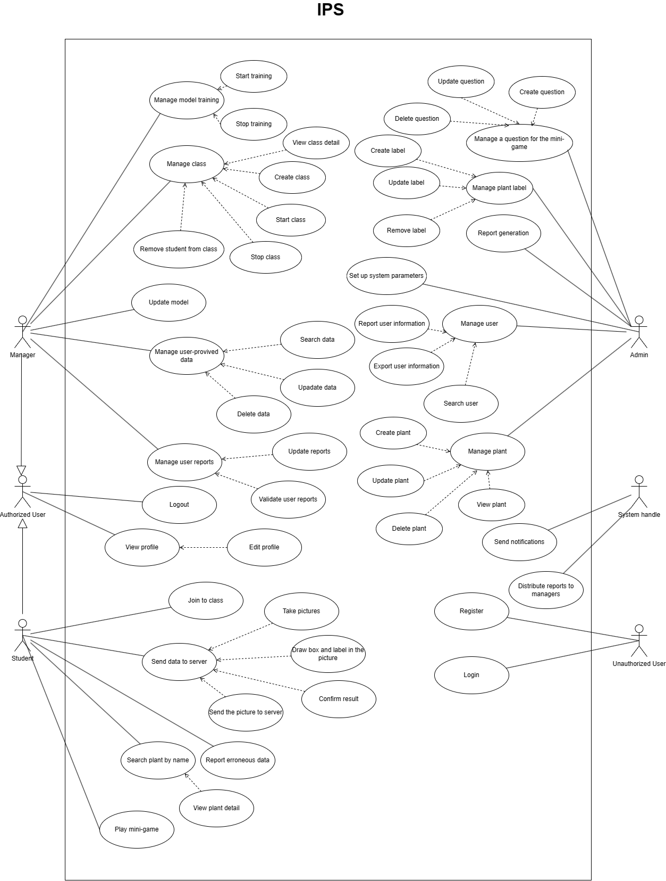

Figure 2. Use case diagram

### **2.2 List of use case with description**

|  |  |  |  |
| --- | --- | --- | --- |
| **ID** | **Use Case** | **Actors** | **Use Case Description** |
| 1 | Login | Guest | Student mobile application:  This use case allows guests to log into the system with the required field:   * Email   Web application:  This use case allows guests to log into the system with the required field, based on role to redirect to the Manager page, and Admin page:   * Email * Password |
| 2 | Logout | Authenticated User | Check user information in the cache that has existed to remove.  Then redirect to the login page. |
| 3 | View profile | Student | This use case allows students to see their own profile. The profile included the following fields:   * First and last name * Phone number * Email * Address * Gender * Image |
| 4 | Update profile | Student | This use case allows students to edit personal information such as   * First and last name * Gender * Phone number * Image   The student can’t update the email. |
| 5 | Take picture | Student | This use case allows students to take a picture. |
| 6 | Choose a photo from a device | Student | This use case allows students to choose a photo from a device. |
| 7 | Draw box and label the picture | Student | This use case allows students to draw labels in the picture to clarify the object to be identified. |
| 8 | Send a picture | Student | This use case allows students to send a picture to detect. |
| 9 | Detect a photo | Student | This use case allows students to detec a photo. |
| 10 | Receive result | Student | This use case allows students to recdetect results from their request.  The result included the following fields:   * Picture (student send) * Name plant(base on leaf) * Plant category * The link path to Wikipedia. |
| 11 | Search Plant by Name | Student | This use case allows students to search plants by name. |
| 12 | Report erroneous data | Student | This use case allows students to report misidentification of plants. |
| 13 | Receive notification | Student, Manager | This use case allows users to receive notifications.  + Students receive a notification when they get the report result, plant detected.  + Students receive a notification when the manager sends them the invitation to class.  + Student receives a notification when the admin sends the report.  + The manager receives a notification when the student sends the report for new data or wrong detected.  + The manager receives a notification when the admin sends the report. |
| 14 | View reports list | Manager, Students | This use case allows managers to view list reports from students. |
| 15 | View report detail | Manager | This use case allows managers to view report details. |
| 16 | Update Report | Manager | This use case allows managers to accept reports and send results back to students. |
| 17 | Validate user report | Manager | This use case allows managers to validate reports from students. |
| 18 | Search plant data | Manager | This use case allows managers to search data that is already available. |
| 19 | Update plant data | Manager | This use case allows managers to update data. |
| 20 | Delete plant data | Manager | This use case allows managers to delete data. |
| 21 | Create class | Manager | This use case allows managers to create classes ( class is used to limit data received from students ). |
| 22 | Start class | Manager | This use case allows managers to start the class. |
| 23 | Stop class | Manager | This use case allows managers to stop the class. |
| 24 | Remove student from class | Manager | This use case allows managers to remove students from the class. |
| 25 | Invited student to class | Manager | This use case allows managers to invite students to class. |
| 26 | Train new root AI | Admin | This use case allows the admin training new AI for the system. |
| 27 | Start training | Admin | This use case allows managers to start training the AI model. |
| 28 | Stop training | Admin | This use case allows managers to stop the training. |
| 29 | Set up AI root model | Admin | This use case allows the admin to update root AI of the system. |
| 30 | View class list | Admin | This use case allows the admin to view all class. |
| 31 | View class detail | Admin | This use case allows the admin to view class detail |
| 32 | Search user | Admin | This use case allows the admin to search all users including managers and students. |
| 33 | Report user information | Admin | This use case allows the admin to report user information. |
| 34 | Export user information | Admin | This use case allows the admin to export the user's information to Excel. |
| 35 | Create mini-game | Admin | This use case allows the admin to create questions for the mini-game. |
| 36 | Play mini game | Student | This use case allows students to play mini-games to test plant's knowledge. |
| 37 | Join class | Student | This use case allows students to join the class by scanning the QR code. |
| 38 | Leaves class | Student | This use case allows students to leave class. |
| 39 | View label | Admin | This use case allows the admin to view the label. |
| 40 | Create label | Admin | This use case allows the admin to create the label. |
| 41 | Update label | Admin | This use case allows the admin to update the label. |
| 42 | Delete label | Admin | This use case allows the admin to delete the label. |
| 43 | Train new root AI | Admin | This use case allows the admin to train new AI for the system. |
| 44 | Update AI for Class | Manager | This use case allows managers to update new AI for their class. |
| 45 | Create plant | Admin | This use case allows the admin create new plant. |

Table 12: Use case list

## 3. Functional Requirements:

**3.1 Create class**

**●** Function trigger: manager click on “+” button to create class

**●** Function description:

* Actor : Manager
* Purpose: To let manager create class for managing student

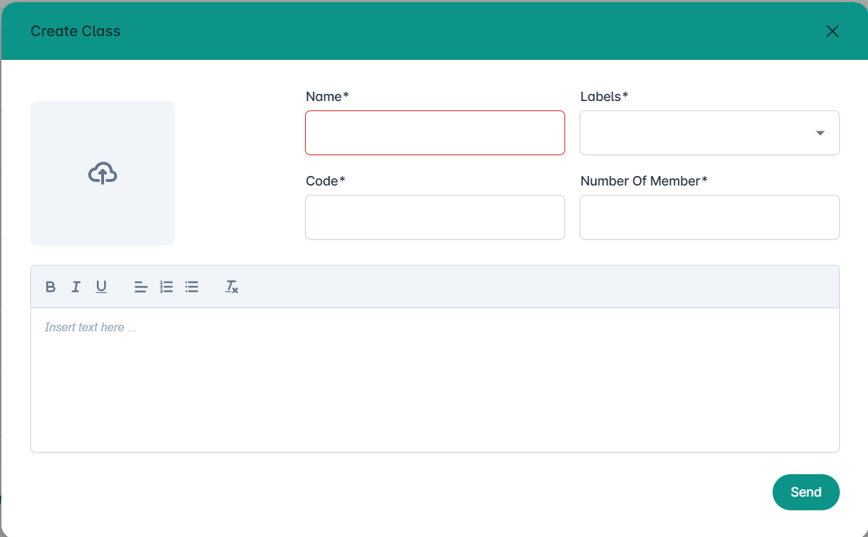

Figure 3. Create class

**3.2 Approve/reject class creation requests**

**●** Function trigger: admin click on “classes” section to approve/reject class creation requests from manager

**●** Function description:

* Actor : Admin
* Purpose: To let admin manage class creation requests from manager

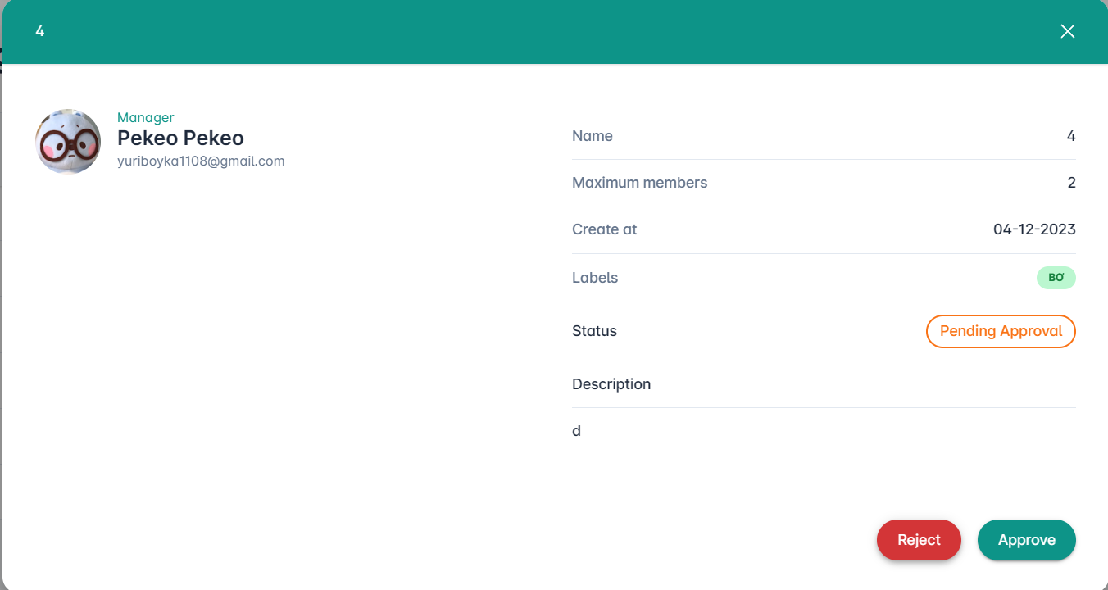

Figure 4. Approve/Reject class

**3.3 Join class with QR code or class code**

**●** Function trigger: Student click on “Enroll class with QR Code” or “Enroll class with Class Code” button to enroll class by QR Code or Class Code

**●** Function description:

* Actor : Student
* Purpose: To let student enroll class with QR Code or Class Code

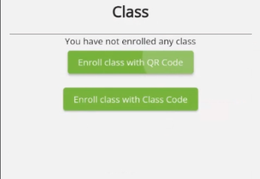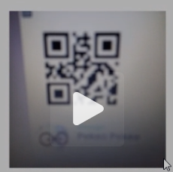

Figure 5. Join class

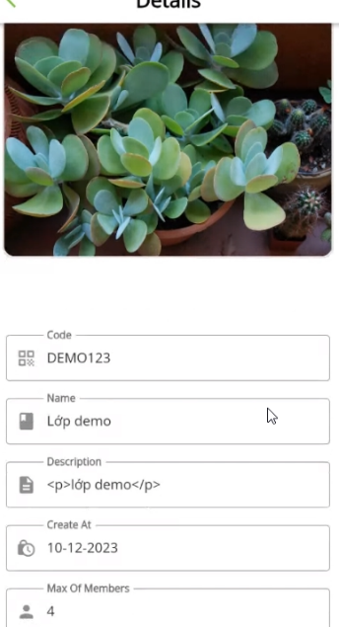

Figure 6. Class detail

**3.4 Plant Detect**

**●** Function trigger: Student click on “Camera” section to take photos that help identify plant

**●** Function description:

* Actor : Student
* Purpose: To let student identify what kind of leaves this plant is

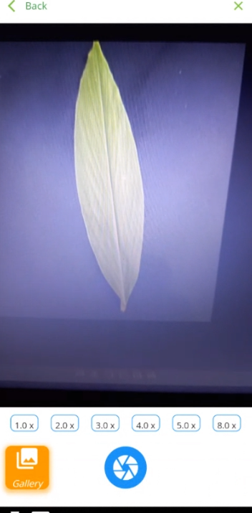

Figure 7. Plant detection

**3.5 Send Report**

**●** Function trigger: Student click on “Send data” button in class to send a report on the type of leaves discovered by the student

**●** Function description:

* Actor : Student
* Purpose: To let student provide data about new plants that the system has not yet recognized

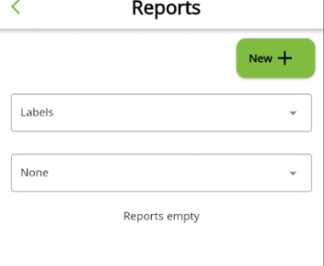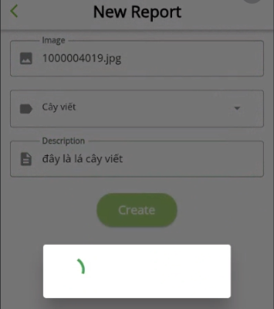

Figure 8. Send report

**3.6 Approve/reject report requests**

**●** Function trigger: Manager click on “Report management” section to approve/reject the student's submission

**●** Function description:

* Actor : Manager
* Purpose: To let manager manage the student’s submission

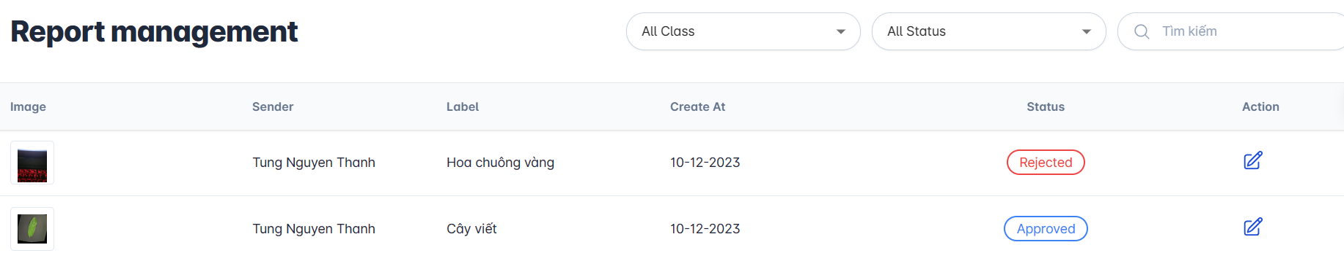

Figure 9. Approve/Deny report

**Rejected report**

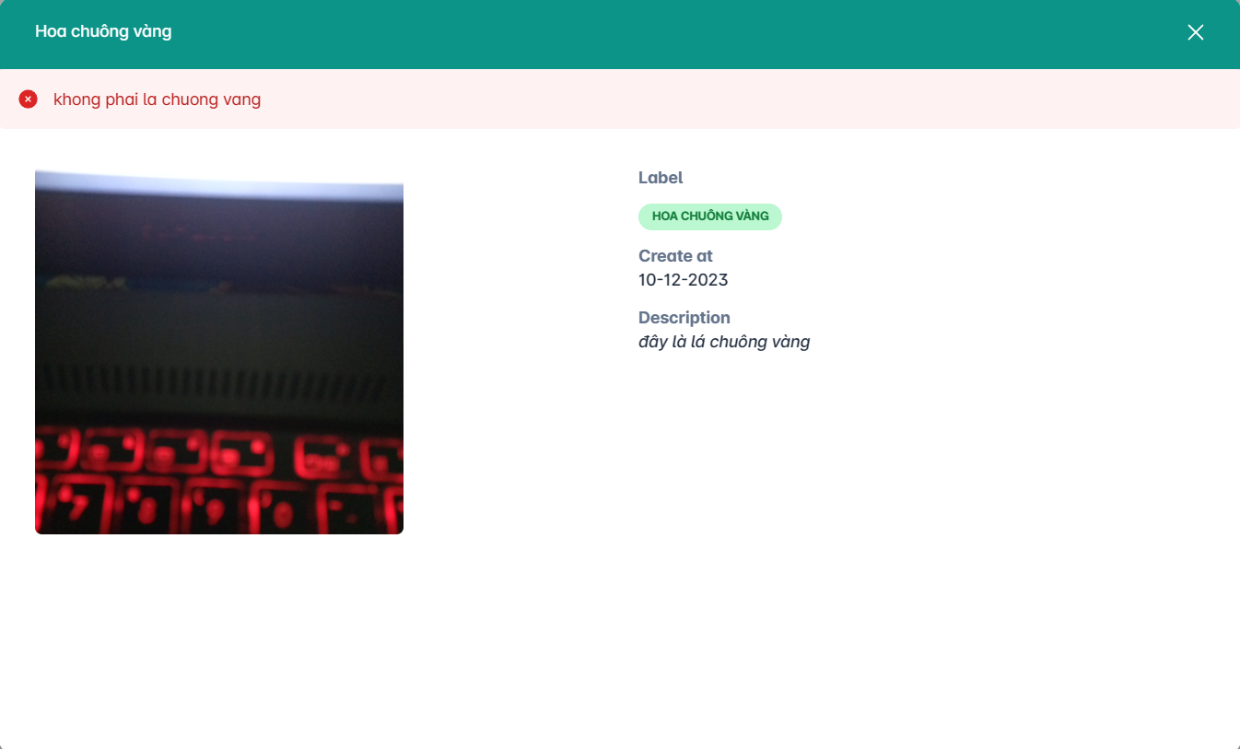

Figure 10.1. Reject report

**Approved report**

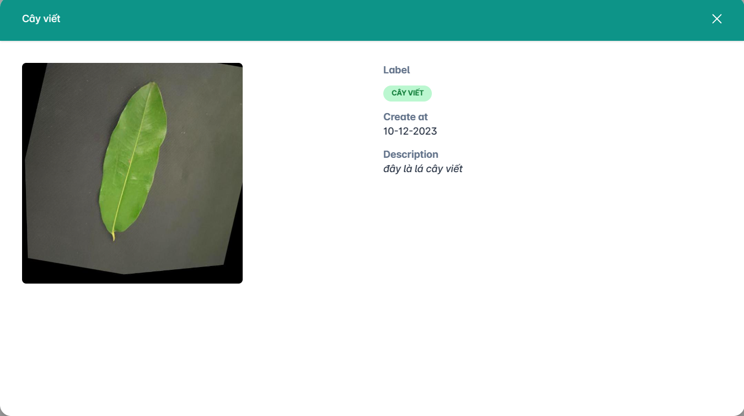

Figure 10.2. Approve report

## 4. Non-Functional Requirements

### **4.1 External Interfaces**

#### 4.1.1 User Interfaces

* The Language used in the application is Vietnamese.

#### 4.1.2 Communications Interfaces

* The system can call API through data transferred by HTTP

### **4.2 Quality Attributes**

#### 4.2.1 Usability

* Ensure that the mobile app for students.
* It doesn’t take too long for the system to return results.
* The system should be friendly and easy for end users to use without training.

#### 4.2.2 Maintenance

* The System must be easy to extend or maintain by dividing it into many modules.

#### 4.2.3 Security

* All input data are validated before saving to the database.
* Each role of the user has specific permission to interact with the system.

#### 4.2.4 Reliability

* The system can be used by multiple users concurrently.
* Availability: 24/24 hours.

#### 4.2.4 Supportability

* The system is separated into front-end, back-end, and mobile applications.
* Back-end: RESTful API should be applied.

## 5. Requirement Appendix

## 5. Requirement Appendix

### **5.1 Business Rules**

|  |  |
| --- | --- |
| **ID** | **Rule Definition** |
| BR-01 | Only the admin can access and modify sensitive AI models or data. |
| BR-02 | Access to certain features or functionalities is restricted based on user roles (admin, manager, user). |
| BR-03 | Input data must meet specified quality standards to ensure accurate model training and predictions. |
| BR-04 | Data preprocessing guidelines should be followed to enhance the effectiveness of the AI model. |
| BR-05 | Continuous monitoring for biases and fairness in AI predictions is implemented. |
| BR-06 | User feedback is collected and used to improve the AI model and overall user experience. |
| BR-07 | Managers pre-set required plant types for student submissions, emphasizing class-specific focus and organizational efficiency across diverse class requirements. |
| BR-08 | Users who join a class are granted the ability to submit reports. |
| BR-09 | Accuracy depends on the size of the dataset; larger datasets have higher accuracy. Additionally, the AI's recognition performance tends to be lower with fewer training images. |
| BR-10 | Improved AI recognition in image object identification is influenced by various factors. Notably, higher-resolution images enhance the clarity of leaf characteristics, leading to higher accuracy in identification. |
| BR-11 | The system requires a status of approval or rejection to be recorded. |
| BR-12 | Performance benchmarks and thresholds are established and monitored to ensure optimal application performance. |
| BR-13 | Data privacy laws and regulations are strictly followed in the collection and handling of user data. |
| BR-14 | In the event of rejecting user-submitted data, a specific reason must be provided. |
| BR-15 | The management and review of these reports are the responsibility of the respective class manager, ensuring organized and class-specific oversight of submitted information. |
| BR-16 | Can not use detected in the class interface before the manager updates AI. |
| BR-17 | Administrator approval is required before classes begin. |
| BR-18 | Only labels that the admin has created can be selected when creating a new class. |
| BR-19 | Only the admin can create a new plant. |
| BR-20 | When class stops, students can not use any function of class. |
| BR-21 | Admin will not censor the report. |
| BR-22 | Students can use the AI feature inside the class after the manager updates. |
| BR-23 | Due to human resources and funding issues, there are not many identifiable tree species. |

*Table 14. Business Rule*

### **5.2 Application Messages List**

|  |  |  |  |  |
| --- | --- | --- | --- | --- |
| **#** | **Message code** | **Message Type** | **Context** | **Content** |
| 1 | MSG01 | In red, bottom of class box | Reason reject class | *“Reason” reject class.* |
| 2 | MSG02 | In red, under the text box | Input-required fields are empty | *The * field is required.* |
| 3 | MSG03 | Toast message | Updating asset(s) information successfully | *Update asset(s) successfully.* |
| 4 | MSG04 | Toast message | Adding new asset successfully | *Add asset successfully.* |

*Table 55. Message List Requirement*

# IV. Software Design Description

## 1. System Design

### 1.1 System Architecture

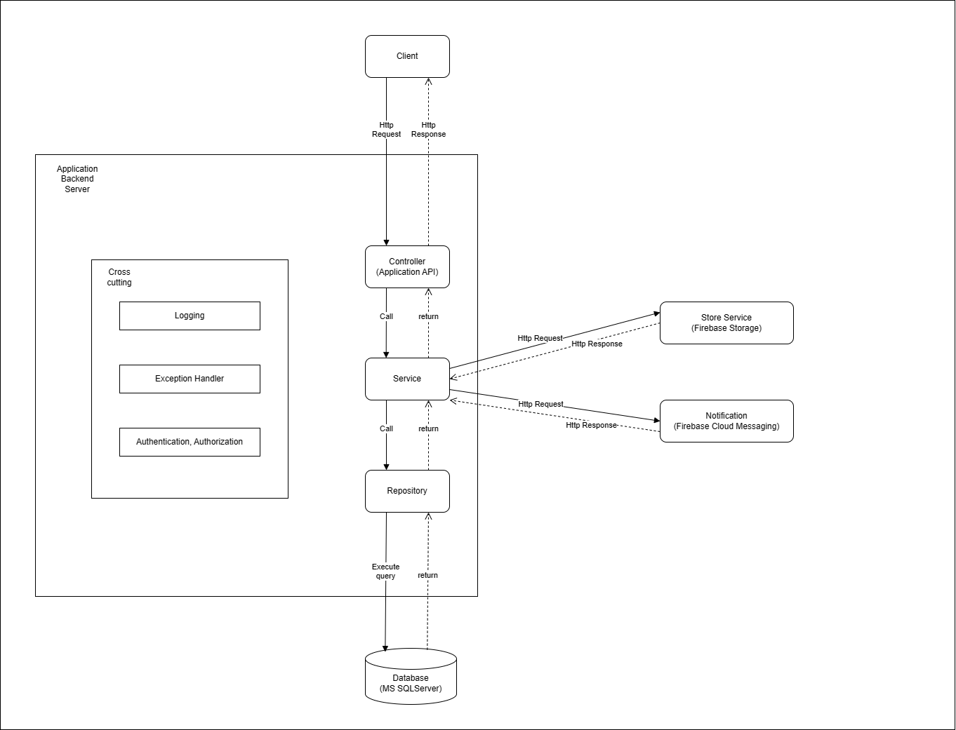

*Figure 11. System Architecture Diagram*

|  |  |  |
| --- | --- | --- |
| **No.** | **Name** | **Description** |
| **1** | **Third Party** | Handle automatic and real-time contact of the system Storage Service and Notification Service are invoked by the Client Side. Storage Service will return that we can store it on the cloud and return quickly without using query in the database. Notification Service will return a notification with all applications we set up for it with low response time. |
| **2** | **Client Side** | This side represents the UI in the system. This handles Web Application and Mobile Application |
| **2.1** | **Web Application** | Applied for Admin, Receptionist, Manager |
| **2.2** | **Mobile Application** | Applied for Customer, Expert |
| **3** | **Server Side** | Logical Side |
| **3.1** | **Back End** | This side will handle all logic of the system. Following those steps above to build a working flow and return data for the Client Side to render it on UI. |

*Table 15. System Architecture Diagram Description*

### 1.2 Package Diagram

#### 1.2.1 Mobile Package Diagram

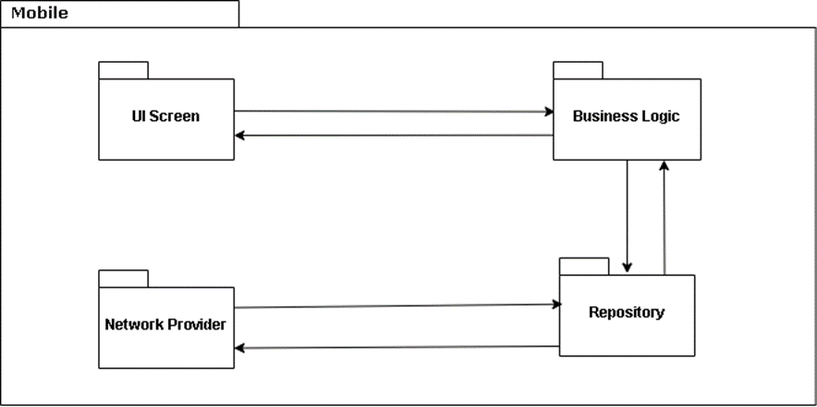

*Figure 12. Mobile Package Diagram*

|  |  |  |
| --- | --- | --- |
| **No** | **Package** | **Description** |
| 1 | UI Screen | End-user devices to display application data receive |
| 2 | Business Logic | Is used to handle app state, store retrieve, submit events, the business logic of the app |
| 3 | Repository | Is used to contain all the functions such as calling HTTP requests, storing data, and receiving responses from the back end through Restful API |
| 4 | Network Provider | The package includes application data |

*Table 16. Mobile Package Diagram Description*

#### 1.2.2 Backend Package Diagram

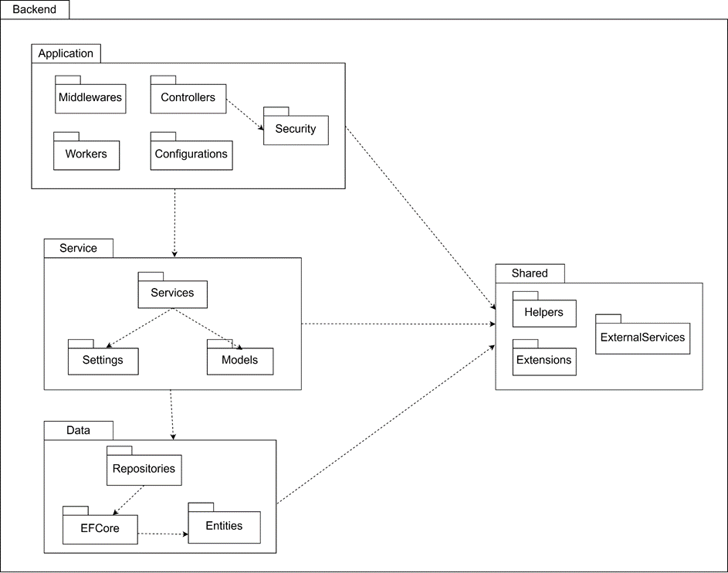

*Figure 13. Backend Package Diagram*

|  |  |  |
| --- | --- | --- |
| **No** | **Package** | **Description** |
| 1 | Controllers | Includes classes for controllers responsible for handling HTTP requests and returning HTTP response |
| 2 | Middlewares | Includes classes for middlewares handle http pipeline |
| 3 | Workers | Includes classes for background service workers |
| 4 | Configurations | Includes classes for configure backend application |
|  | Security | Includes classes handle authorization, and authentication |
| 5 | Services | Includes classes for business logic services |
| 6 | Settings | Includes settings classes for services |
| 7 | Models | Includes settings classes for data transfer objects (dtos) |
| 8 | Repositories | The package includes abstraction classes to execute read/write operations to database |
| 9 | EFCore | Manage database connection, directly execute database queries, entity relational mapping. |
| 10 | Entities | Includes all application entity classes, map with database schema |
| 11 | Helpers | Includes all the utility classes for application |
| 12 | Extensions | Includes application extension classes |
| 13 | ExternalServices | Includes external services like Google Cloud, Firebase |

*Table 17. Backend Package Diagram Description*

## 2. Database Design

### **2.1. Entity Relationship Diagram**

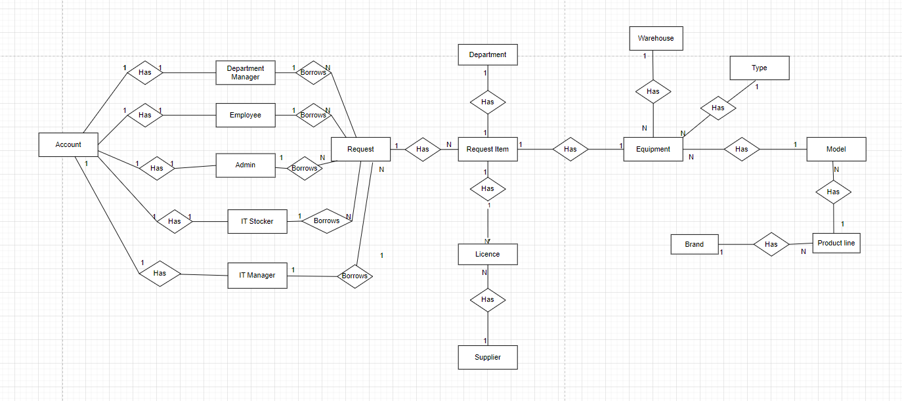

*Figure 14. Entity Relationship Diagram (ERD)*

### **2.2. Database Diagram**

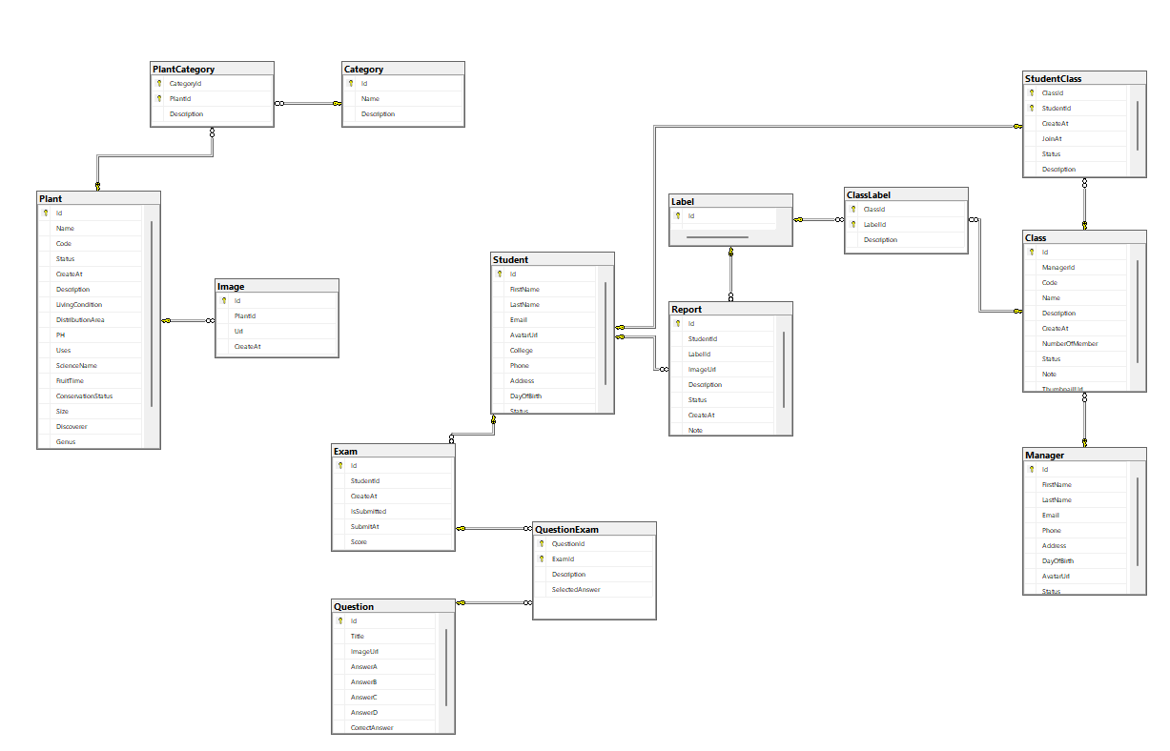

*Figure 15. Database Diagram*

### **2.3. Data Dictionary**

#### 2.3.1. Category

|  |  |  |  |  |  |  |
| --- | --- | --- | --- | --- | --- | --- |
| **#** | **Field name** | **Type** | **Unique** | **Not null** | **PK/FK** | **Notes** |
| 1 | Id | uniqueidentifier | x | x | PK | Identifier for each category |
| 2 | Name | nvarchar(256) |  | x |  | Name of the category |
| 3 | Description | nvarchar(MAX) |  |  |  | Description of the category |

*Table 18. Category Table*

#### 2.3.2. Class

|  |  |  |  |  |  |  |
| --- | --- | --- | --- | --- | --- | --- |
| **#** | **Field name** | **Type** | **Unique** | **Not null** | **PK/FK** | **Notes** |
| 1 | Id | uniqueidentifier | x | x | PK | Identifier for each class |
| 2 | ManagerId | uniqueidentifier |  | x |  | Identifier for each manager |
| 3 | Name | nvarchar(256) |  | x |  | Name of the class |
| 4 | Description | nvarchar(MAX) |  |  |  | Description of the class |
| 5 | CreatedAt | datetime |  | x |  | Timestamp of when the class record was created |
| 6 | NumberOfMember | int |  | x |  | Number of members in that class |
| 7 | Status | nvarchar(256) |  | x |  | The class state is open or closed |

*Table 19. Class Table*

#### 2.3.3. ClassLabel

|  |  |  |  |  |  |  |
| --- | --- | --- | --- | --- | --- | --- |
| **#** | **Field name** | **Type** | **Unique** | **Not null** | **PK/FK** | **Notes** |
| 1 | ClassId | uniqueidentifier | x | x | PK,FK | Identifier for the class |
| 2 | LabelId | uniqueidentifier |  | x | PK,FK | Identifier for the label |
| 3 | Description | nvarchar(MAX) |  |  |  | Description of the class label association |

*Table 20. Class Label Table*

#### 2.3.4. Exam

|  |  |  |  |  |  |  |
| --- | --- | --- | --- | --- | --- | --- |
| **#** | **Field name** | **Type** | **Unique** | **Not null** | **PK/FK** | **Notes** |
| 1 | Id | uniqueidentifier | x | x | PK | Primary key of the exam |
| 2 | StudentId | uniqueidentifier |  | x | FK | Identifier for the student taking the exam |
| 3 | CreateAt | datetime |  | x |  | Timestamp of when the exam was created |
| 4 | IsSubmitted | bit |  | x |  | Indicator if the exam has been submitted |
| 5 | SubmitAt | datetime |  | x |  | The time the test was submitted |
| 6 | Score | float |  | x |  | Results of the Exam |

*Ttable 21. Exam Table.*

#### 2.3.5. Image

|  |  |  |  |  |  |  |
| --- | --- | --- | --- | --- | --- | --- |
| **#** | **Field name** | **Type** | **Unique** | **Not null** | **PK/FK** | **Notes** |
| 1 | Id | uniqueidentifier | x | x | PK | Primary key of the image record |
| 2 | PlantId | uniqueidentifier |  | x |  | Identifier linking the image to a specific plant |
| 3 | Url | nvarchar(MAX) |  | x |  | URL of the image |
| 4 | CreateAt | datetime |  | x |  | Timestamp of when the image record was created |

*table 22. Image Table*

#### 2.3.6. Label

|  |  |  |  |  |  |  |
| --- | --- | --- | --- | --- | --- | --- |
| # | Field name | Type | Unique | Not null | PK/FK | Notes |
| 1 | Id | uniqueidentifier | x | x | PK | Primary key of the label |
| 2 | Name | nvarchar(256) |  | x |  | Name or title of the label |

*Table 23. Label Table*

#### 2.3.7. Manager

|  |  |  |  |  |  |  |
| --- | --- | --- | --- | --- | --- | --- |
| **#** | **Field name** | **Type** | **Unique** | **Not null** | **PK/FK** | **Notes** |
| 1 | Id | uniqueidentifier | x | x | PK | Primary key of manager user reference id |
| 2 | FirstName | nvarchar(256) |  | x |  | Manager's first name |
| 3 | LastName | nvarchar(256) |  | x |  | Manager's last name |
| 4 | Email | nvarchar(256) |  | x |  | Manager's email address |
| 5 | Phone | nvarchar(256) |  | x |  | Manager's phone |
| 6 | Address | nvarchar(MAX) |  | x |  | Manager's address |
| 7 | DayOfBirth | nvarchar(256) |  | x |  | Manager's date of birth |
| 8 | AvatarUrl | nvarchar(MAX) |  | x |  | URL of the manager's avatar image |
| 9 | Status | nvarchar(256) |  | x |  | Manager's current status |

*Table 24. Manager Table*

#### 2.3.8. Plant

|  |  |  |  |  |  |  |
| --- | --- | --- | --- | --- | --- | --- |
| **#** | **Field name** | **Type** | **Unique** | **Not null** | **PK/FK** | **Notes** |
| 1 | Id | uniqueidentifier | x | x | PK | Primary key of the plant record |
| 2 | Name | nvarchar(256) |  | x |  | Name of the plant |
| 3 | Code | nvarchar(256) |  | x |  | Unique code identifier for the plant |
| 4 | Status | nvarchar(256) |  | x |  | Current status of the plant |
| 5 | CreateAt | datetime |  | x |  | Timestamp of when the plant record was created |

*Table 25. Plant Table*

#### 2.3.9. Plant Category

|  |  |  |  |  |  |  |
| --- | --- | --- | --- | --- | --- | --- |
| **#** | **Field name** | **Type** | **Unique** | **Not null** | **PK/FK** | **Notes** |
| 1 | CategoryId | uniqueidentifier | x | x | PK | primary key of plant category |
| 2 | PlantId | uniqueidentifier |  | x | PK | linking to a specific plant |
| 3 | Description | nvarchar(MAX) |  |  |  | Provides additional information about the plant category |

*Table 26. PlanCategory Table*

#### 2.3.10. Question

|  |  |  |  |  |  |  |
| --- | --- | --- | --- | --- | --- | --- |
| **#** | **Field name** | **Type** | **Unique** | **Not null** | **PK/FK** | **Notes** |
| 1 | Id | uniqueidentifier | x | x | PK | Primary key of the question |
| 2 | Title | nvarchar(MAX) |  | x |  | Title of the question |
| 3 | ImageUrl | nvarchar(MAX) |  |  |  | URL of an image associated with the question |
| 4 | AnswerA | nvarchar(MAX) |  | x |  | Indicates answer A |
| 5 | AnswerB | nvarchar(MAX) |  | x |  | Indicates answer B |
| 6 | AnswerC | nvarchar(MAX) |  | x |  | Indicates answer C |
| 7 | AnswerD | nvarchar(MAX) |  | x |  | Indicates answer D |
| 8 | CorrectAnswer | char(1) |  | x |  | Indicates correct answer |

*Table 27. Question Table*

#### 2.3.11. QuestionExam

|  |  |  |  |  |  |  |
| --- | --- | --- | --- | --- | --- | --- |
| **#** | **Field name** | **Type** | **Unique** | **Not null** | **PK/FK** | **Notes** |
| 1 | QuestionId | uniqueidentifier | x | x | PK | Primary key of the question exam |
| 2 | ExamId | uniqueidentifier |  | x | PK | Primary key of the exam |
| 3 | Description | nvarchar(MAX) |  |  |  | Provides additional information about the exam |
| 4 | SelectedAnswer | char(1) |  |  |  | indicates that the answer is being selected |

*Table 28. QuestionExam Table*

#### 2.3.12. Report

|  |  |  |  |  |  |  |
| --- | --- | --- | --- | --- | --- | --- |
| **#** | **Field name** | **Type** | **Unique** | **Not null** | **PK/FK** | **Notes** |
| 1 | Id | uniqueidentifier | x | x | PK | Primary key of the report |
| 2 | StudentId | uniqueidentifier |  |  |  | Identifier for the student who created the report |
| 3 | ImageUrl | nvarchar(MAX) |  |  |  | URL of the image associated with the report |
| 4 | Label | nvarchar(256) |  |  |  | Identifier for the label associated with the report |
| 5 | Description | nvarchar(MAX) |  | x |  | Description or details of the report |
| 6 | Status | nvarchar(256) |  |  |  | Current status of the report |
| 7 | CreateAt | datetime |  |  |  | Timestamp when the report was created |

*Table 29. Report Table*

#### 2.3.13. Student

|  |  |  |  |  |  |  |
| --- | --- | --- | --- | --- | --- | --- |
| **#** | **Field name** | **Type** | **Unique** | **Not null** | **PK/FK** | **Notes** |
| 1 | Id | uniqueidentifier | x | x | PK | Primary key of the student |
| 2 | FirstName | nvarchar(256) |  | x |  | First name of the student |
| 3 | LastName | nvarchar(256) |  | x |  | Last name of the student |
| 4 | Email | nvarchar(256) |  | x |  | Email address of the student |
| 5 | AvatarUrl | nvarchar(MAX) |  |  |  | URL of the student's avatar image |
| 6 | College | nvarchar(256) |  |  |  | Name of the college or university the student attends |
| 7 | Phone | nvarchar(256) |  |  |  | Phone number of the student |
| 8 | Address | nvarchar(MAX) |  |  |  | Home address of the student |
| 9 | DayOfBirth | nvarchar(256) |  |  |  | Date of birth of the student |
| 10 | Status | nvarchar(256) |  | x |  | Current status of the student |

*Table 30. Student Table*

#### 2.3.14. StudentClass

|  |  |  |  |  |  |  |
| --- | --- | --- | --- | --- | --- | --- |
| **#** | **Field name** | **Type** | **Unique** | **Not null** | **PK/FK** | **Notes** |
| 1 | ClassId | uniqueidentifier |  | x | PK,FK | linking the student to a specific class |
| 2 | StudentId | uniqueidentifier |  | x | PK,FK | associating the class with a specific student |
| 3 | CreateAt | datetime |  | x |  | Timestamp of when the student-class association was created |
| 4 | JoinAt | datetime |  |  |  | Timestamp of when the student joined the class |
| 5 | Status | nvarchar(256) |  | x |  | Current status of the student in the class |
| 6 | Description | nvarchar(MAX) |  |  |  | Description about the student-class |

*Table 31. Student Class Table*

#### 2.3.15. HangFire.AggregatedCounter

|  |  |  |  |  |  |  |
| --- | --- | --- | --- | --- | --- | --- |
| **#** | **Field name** | **Type** | **Unique** | **Not null** | **PK/FK** | **Notes** |
| 1 | [Key] | nvarchar(100) | x | x | PK | primary key |
| 2 | Value | bigint |  | x |  |  |
| 3 | ExpireAt | datetime |  |  |  |  |

*Table 32. HangFire.AggregatedCounter Table*

#### 2.3.16. HangFire.Counter

|  |  |  |  |  |  |  |
| --- | --- | --- | --- | --- | --- | --- |
| **#** | **Field name** | **Type** | **Unique** | **Not null** | **PK/FK** | **Notes** |
| 1 | [Key] | nvarchar(100) | x | x | PK | primary key |
| 2 | Value | int |  | x |  |  |
| 3 | ExpireAt | datetime |  |  |  |  |
| 4 | Id | bigint |  | x | FK |  |

*Table 33. HangFire.Counter Table*

#### 2.3.17. HangFire.Hash

|  |  |  |  |  |  |  |
| --- | --- | --- | --- | --- | --- | --- |
| **#** | **Field name** | **Type** | **Unique** | **Not null** | **PK/FK** | **Notes** |
| 1 | [Key] | nvarchar(100) | x | x | PK | primary key |
| 2 | Field | nvarchar(100) |  | x | FK |  |
| 3 | Value | nvarchar(MAX) |  |  |  |  |
| 4 | ExpireAt | datetime2(7) |  |  |  |  |

*Table 34. Hash Table*

#### 2.3.18. HangFire.Job

#### 

|  |  |  |  |  |  |  |
| --- | --- | --- | --- | --- | --- | --- |
| **#** | **Field name** | **Type** | **Unique** | **Not null** | **PK/FK** | **Notes** |
| 1 | Id | bigint | x | x | PK | primary key |
| 2 | StateId | bigint |  |  |  |  |
| 3 | StateName | nvarchar(20) |  |  |  |  |
| 4 | InvocationData | nvarchar(MAX) |  | x |  |  |
| 5 | Arguments | nvarchar(MAX) |  | x |  |  |
| 6 | CreatedAt | datetime |  | x |  |  |
| 7 | ExpireAt | datetime |  |  |  |  |

*Table 35. Job Table*

#### 2.3.19. HangFire.JobParameter

#### 

|  |  |  |  |  |  |  |
| --- | --- | --- | --- | --- | --- | --- |
| **#** | **Field name** | **Type** | **Unique** | **Not null** | **PK/FK** | **Notes** |
| 1 | JobId | bigint | x | x | PK | primary key |
| 2 | Name | nvarchar(40) |  | x | FK |  |
| 3 | Value | nvarchar(MAX) |  |  |  |  |

*Table 36. JobPaarameter Table*

#### 2.3.20. HangFire.JobQueue

#### 

|  |  |  |  |  |  |  |
| --- | --- | --- | --- | --- | --- | --- |
| **#** | **Field name** | **Type** | **Unique** | **Not null** | **PK/FK** | **Notes** |
| 1 | Id | bigint | x | x | PK | primary key |
| 2 | JobId | bigint |  | x |  |  |
| 3 | Queue | nvarchar(50) |  | x | FK |  |
| 4 | FetchedAt | datetime |  |  |  |  |

*Table 37. JobQueue Table*

#### 2.3.21. HangFire.List

#### 

|  |  |  |  |  |  |  |
| --- | --- | --- | --- | --- | --- | --- |
| **#** | **Field name** | **Type** | **Unique** | **Not null** | **PK/FK** | **Notes** |
| 1 | Id | bigint | x | x | PK | primary key |
| 2 | [Key] | nvarchar(100) |  | x | FK | t |
| 3 | Value | nvarchar(MAX) |  |  |  |  |
| 4 | ExpireAt | datetime |  |  |  |  |

*Table 38. List Table*

#### 2.3.22. HangFire.Schema

#### 

|  |  |  |  |  |  |  |
| --- | --- | --- | --- | --- | --- | --- |
| **#** | **Field name** | **Type** | **Unique** | **Not null** | **PK/FK** | **Notes** |
| 1 | Version | int | x | x | PK | primary key |

*Table 39. Schema Table*

#### 2.3.23. HangFire.Server

#### 

|  |  |  |  |  |  |  |
| --- | --- | --- | --- | --- | --- | --- |
| **#** | **Field name** | **Type** | **Unique** | **Not null** | **PK/FK** | **Notes** |
| 1 | Id | nvarchar(200) | x | x | PK | primary key |
| 2 | Data | nvarchar(MAX) |  |  |  |  |
| 3 | LastHeartbeat | datetime |  | x |  |  |

*Table 40. Server Table*

#### 2.3.24. HangFire.Set

|  |  |  |  |  |  |  |
| --- | --- | --- | --- | --- | --- | --- |
| **#** | **Field name** | **Type** | **Unique** | **Not null** | **PK/FK** | **Notes** |
| 1 | [Key] | nvarchar(100) | x | x | PK | primary key |
| 2 | Score | float |  | x |  |  |
| 3 | Value | nvarchar(256) |  | x | FK |  |
| 4 | ExpireAt | datetime |  |  |  |  |

*Table 41. Set Table*

#### 2.3.24. HangFire.State

|  |  |  |  |  |  |  |
| --- | --- | --- | --- | --- | --- | --- |
| **#** | **Field name** | **Type** | **Unique** | **Not null** | **PK/FK** | **Notes** |
| 1 | Id | bigint | x | x | PK | primary key |
| 2 | JobId | bigint |  | x | FK |  |
| 3 | Name | nvarchar(20) |  | x |  |  |
| 4 | Reason | nvarchar(100) |  |  |  |  |
| 5 | CreatedAt | datetime |  | x |  |  |
| 6 | Data | nvarchar(MAX) |  |  |  |  |

*Table 42. State Table*

## 3. Detailed Design

### **3.1 *Detect Plant***

#### *3.1.1 Class Diagram*

#### 

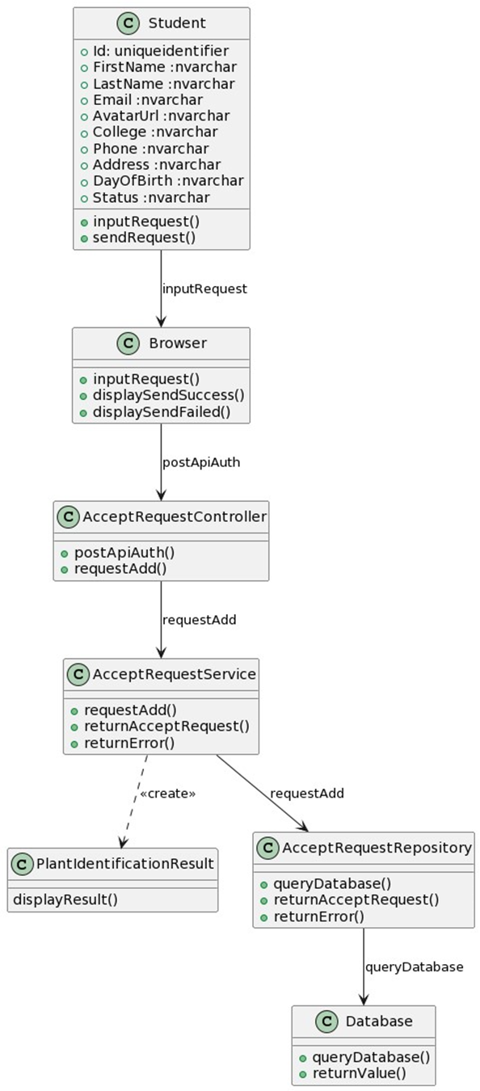

*Figure 16. Detect plant*

#### 3.1.2 Class Specification

##### 

|  |  |  |
| --- | --- | --- |
| **No** | **Method** | **Description** |
| 1 | inputRequest() | Initiates a user's new request, often involving data input through a user interface. |
| 2 | sendRequest(): | Transmits the user's request to a server or service for processing. |
| 3 | displaySendSuccess(): | Shows a confirmation message indicating the request was sent successfully. |
| 4 | displaySendFailed(): | Alerts the user that the request failed to send. |
| 5 | postApiAuth(): | Authenticates a request against an API using provided credentials. |
| 6 | requestAdd(): | Adds a new request to the system, which may involve updating a database. |
| 7 | returnAcceptRequest(): | Confirms the acceptance of a request by the system. |
| 8 | queryDatabase(): | Executes a search or retrieval operation in the database. |
| 9 | returnError(): | Communicates an error back to the user or system following a failed request. |
| 10 | queryDatabase(): | Retrieves data from a database based on the request's parameters. |

*Table 43. Detect Plant Class Specification*

#### 3.1.3 *Sequence Diagram*

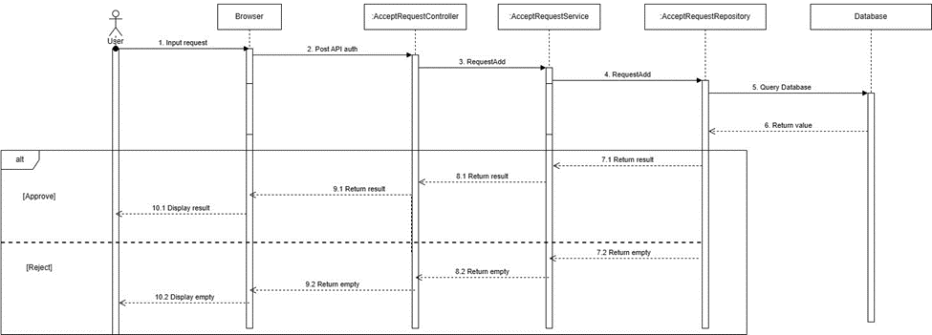

*Figure 17. Detect plant Sequence Diagram*

### **3.2 Class Management**

#### *3.2.1 Class Diagram*

#### 

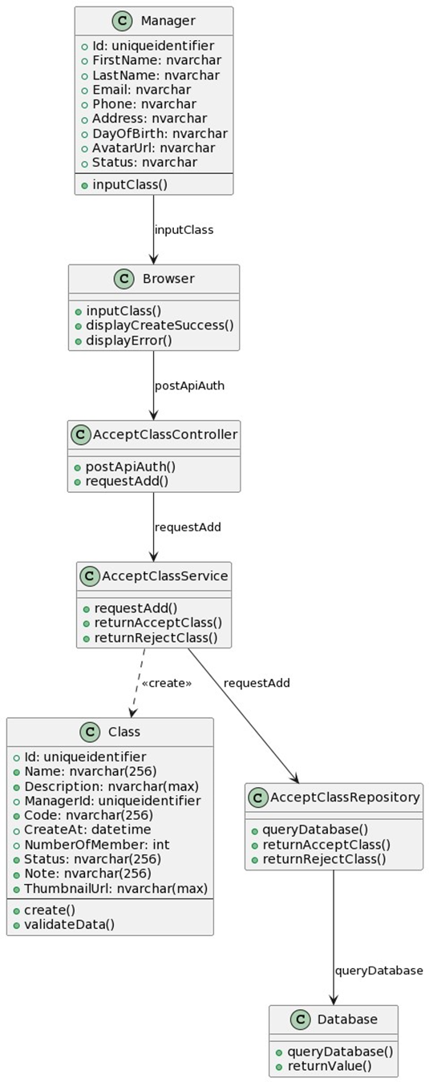

*Figure 18. Class Management*

#### 3.2.2 Class Specification

##### 

|  |  |  |
| --- | --- | --- |
| **No** | **Method** | **Description** |
| 1 | inputClass(): | Captures details for a new class entry from the user. |
| 2 | displayCreateSuccess(): | Informs the user that the class creation was successful. |
| 3 | displayError(): | Shows an error message due to a problem in the process. |
| 4 | postApiAuth(): | Sends authentication data to an API endpoint for verification. |
| 5 | requestAdd(): | Submits a request to add a new record or data entry. |
| 6 | returnAcceptClass(): | Signals successful acceptance of a new class request. |
| 7 | returnRejectClass(): | Indicates rejection of a new class request. |
| 8 | queryDatabase(): | Executes a search or retrieval operation in the database. |
| 9 | validateData(): | Checks the request data for correctness and completeness before processing. |
| 10 | create(): | initialize and save new data entries. |

*Table 44. Class Management Specification*

#### 3.2.3 Sequence Diagram

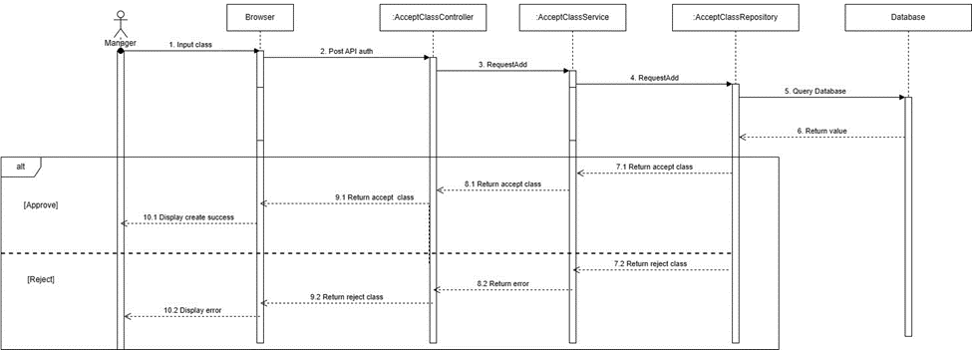*Figure 19. Class Management Sequence Diagram*

### **3.3 User Management**

### 

#### *3.3.1 Class Diagram*

#### 

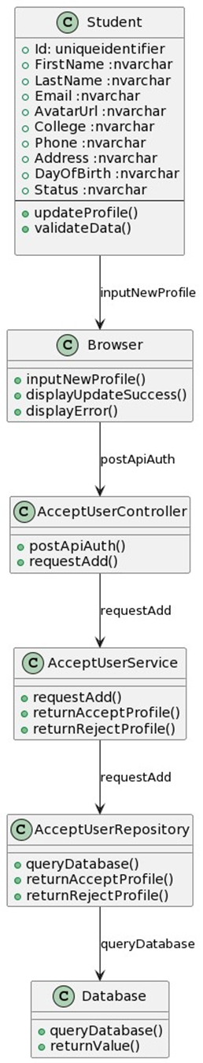

*Figure 21. User Management Class Diagram*

#### 3.3.2 Class Specification

##### 

|  |  |  |
| --- | --- | --- |
| **No** | **Method** | **Description** |
| 1 | updateProfile(): | Applies changes to an existing user profile. |
| 2 | inputNewProfile(): | Collects new profile information from a user. |
| 3 | displayUpdateSuccess(): | Shows a message confirming a successful profile update. |
| 4 | displayError(): | Presents an error message in case of a problem during the process. |
| 5 | validateData(): | Checks the request data for correctness and completeness before processing. |
| 6 | postApiAuth(): | Secures API access through user authentication. |
| 7 | requestAdd(): | Initiates a request to add new data to the system. |
| 8 | returnAcceptProfile(): | Acknowledges the successful update or creation of a profile. |
| 9 | returnRejectProfile(): | Notifies of the rejection or failure to update/create a profile. |
| 10 | queryDatabase(): | Performs a data retrieval operation from the database. |
| 11 | returnValue(): | Outputs the result or value from a process or database query. |

*Table 45. User Management Class Specification*

#### 3.3.3 *Sequence Diagram*

#### 

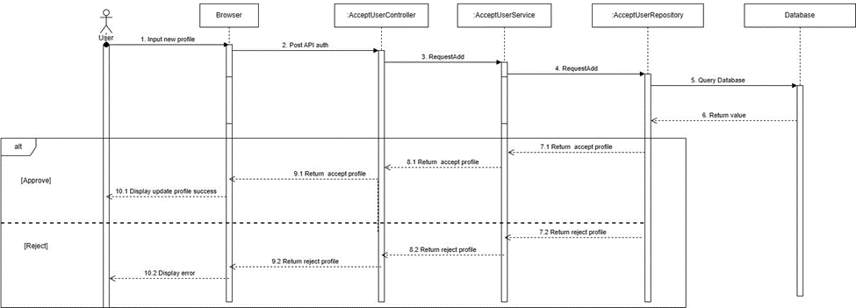

*Figure 22. User Management Sequence Diagram*

### **3.4 Label Management**

#### *3.4.1 Class Diagram*

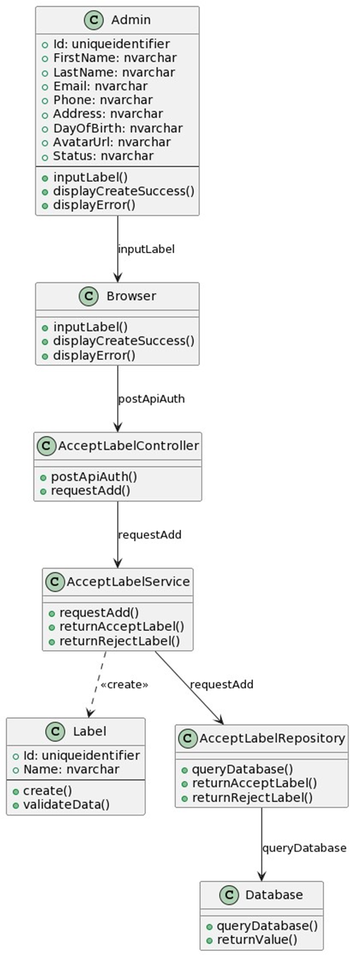

*Figure 23. Label Management Class Diagram*

#### 3.4.2 Class Specification

##### 

|  |  |  |
| --- | --- | --- |
| **No** | **Method** | **Description** |
| 1 | inputLabel(): (): | Gathers new label information for input into the system. |
| 2 | returnAcceptLabel(): | Confirms the successful addition or modification of a label. |
| 3 | returnRejectLabel(): | (): Indicates the rejection or failure of a label addition or update. |
| 4 | displayUpdateSuccess(): | Shows a message confirming a successful profile update. |
| 5 | displayError(): | Presents an error message in case of a problem during the process. |
| 6 | postApiAuth(): | Secures API access through user authentication. |
| 7 | requestAdd(): | Initiates a request to add new data to the system. |
| 8 | queryDatabase(): | Performs a data retrieval operation from the database. |
| 9 | returnValue(): | Outputs the result or value from a process or database query. |
| 10 | validateData(): | Checks the request data for correctness and completeness before processing. |
| 11 | create(): | Constructs a new instance or record in the system, often used to initialize and save new data entries. |

*Table 46. Label Management Class Specification*

#### 

#### 3.4.3 *Sequence Diagram*

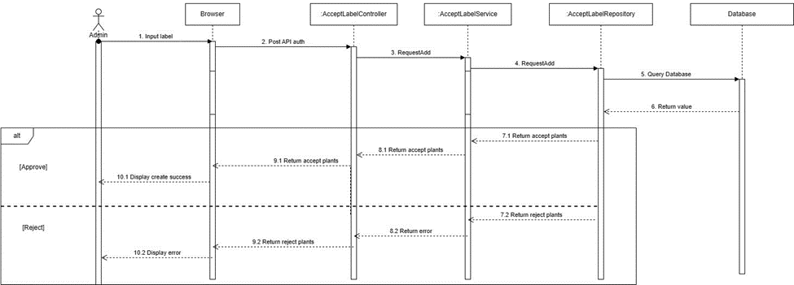

*Figure 24. Label Management Sequence Diagram*

### **3.5 Report Management**

#### *3.5.1 Class Diagram*

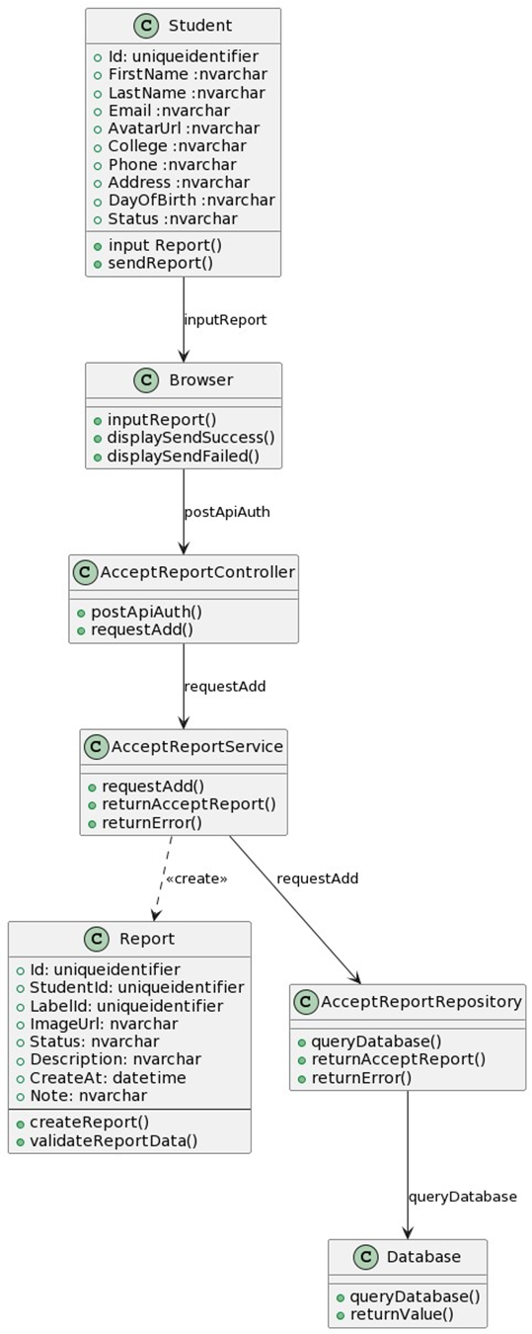

*Figure 25. Report Management Class Diagram*

#### 3.5.2 Class Specification

##### 

|  |  |  |
| --- | --- | --- |
| **No** | **Method** | **Description** |
| 1 | inputReport(): | Collects data and details for a new report from the user. |
| 2 | sendReport(): | Submits the compiled report for processing or review. |
| 3 | displaySendSuccess(): | Shows a message confirming successful report submission. |
| 4 | displaySendFailed(): | Displays an alert if the report fails to send. |
| 5 | displayError(): | Presents an error message in case of a problem during the process. |
| 6 | postApiAuth(): | Secures API access through user authentication. |
| 7 | requestAdd(): | Initiates a request to add new data to the system. |
| 8 | returnAcceptReport(): | Indicates that the submitted report has been accepted. |
| 9 | queryDatabase(): | Performs a data retrieval operation from the database. |
| 10 | createReport(): | Constructs a new report instance in the system. |
| 11 | validateReportData(): | Checks the report data for accuracy and completeness. |
| 12 | returnValue(): | Outputs the final result or decision regarding the report. |

*Table 47. Report Management Class Specification*

#### 3.5.3 *Sequence Diagram*

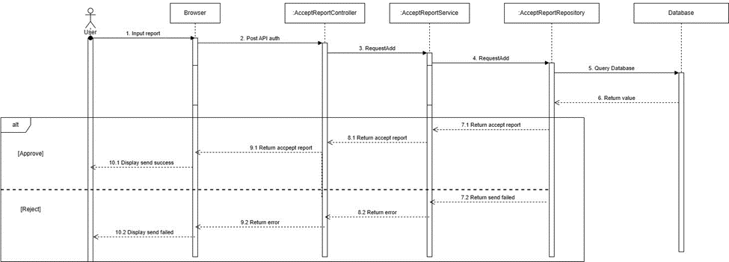

*Figure 26. Report Management Sequence Diagram*

# V. Software Testing Documentation

## 1. Scope of Testing

In project, we apply Incremental testing for many purposes:

* Each Module provides a definitive role to play in the project structure.
* When the implementation is finished, test cases are ready for execution.

## 2. Test Strategy

### **2.1 Testing Types**

In project we apply 3 types of testing:

* Functional test: Ensure that all functions in the system meet its requirements.
* User Interface test: Ensure that UI are correctly presented.

### **2.2 Test Levels**

Testing level that will be performed in the project:

* Integration testing: Ensure every module works together appropriately in the system.
* System testing: Ensure that the Website and Mobile project meets the design specification and other requirements.

## 3. Test Plan

### **3.1 Human Resources**

|  |  |  |
| --- | --- | --- |
| Worker/Doer | Role | Specific Responsibilities/Comments |
| Nguyễn Thanh Tùng | Leader | Planning, assigning test functions to members and verifying test results. |
| Nguyễn Văn Sáng | Member | Execute test and report. |
| Phan Hoàng Chiến | Member | Execute test and report. |
| Lê Minh Khôi | Member | Execute test and report. |

*Table 48. Human Resources*

### **3.2 Test Milestones**

|  |  |
| --- | --- |
| Milestone Task | Due Date |
| Test Document | 9/12/2023 |

*Table 49. Test Milestones*

## 4. Test Cases and Test Reports

Test Cases: [Report5_Test_Case_Document](https://docs.google.com/spreadsheets/d/1lYSf0BbR8qHVuE_9qJ2_QYj2q9S8gLUC/edit?usp=sharing&ouid=110887843617923764536&rtpof=true&sd=true)

Test Report: [Report5_Test Report Document](https://docs.google.com/spreadsheets/d/1URcdfTHzfInQNHNysO1msUpg5CleS_mK/edit?usp=sharing&ouid=110887843617923764536&rtpof=true&sd=true)

# VI. Release Package & User GuidesReport5_Test Case Document

## 1. Deliverable Package

| **No.** | **Deliverable Item** | **Sub-Items** | **Type** | **Version** |
| --- | --- | --- | --- | --- |
| Code package | | | | |
| 1 | Backend Server | Web service | Modify | 1.0 |
| 2 | Mobile | Detection application | Modify | 1.0 |
| Documents | | | | |
| 3 | Final Report Document | Report7_Final Project Report.docx | Modify | 1.0 |
| 4 | Test Cases Document | TestPlan.xlsx | Modify | 1.0 |
| 5 | Slide | SLIDE.pptx | Modify | 1.0 |

*Table 50. Deliverable Package*

## 2.Installation Guides

### **2.1 System Requirements**

|  |  |  |
| --- | --- | --- |
| Component | Minimum | Recommended |
| CPU | At least 2 (GHz) x64-bit | Core i5 or i7 |
| Memory | At least 2GB RAM | At least 4GB RAM |
| Storage Space | 10GB HDD | 20GB HDD |
| Network | Internet Connection | Internet Connection |

*Table 51. System Requirements*

### **2.2 Installation Instruction**

#### 2.2.1 Environment setup

* Download and install .NET 6 Framework.
* Download and install SQL Server 2019
* Download and install any C#, .NET code editor.
* Download and install Flutter 3.13.6 and up.
* Download and install Dart 3.13 and up.
* Download and install any Flutter code editor.
* Download and install Git.
* Authenticate Git repository with GitHub account.
* Pull code from GitHub.

#### 2.2.2 Run Backend Server

* Pull code from repository [TungThnh/Capstone-PlantDetection-Backend: Backend](https://github.com/TungThnh/Capstone-PlantDetection-Backend)
* Open project in visual studio.
* Change app settings configuration files.

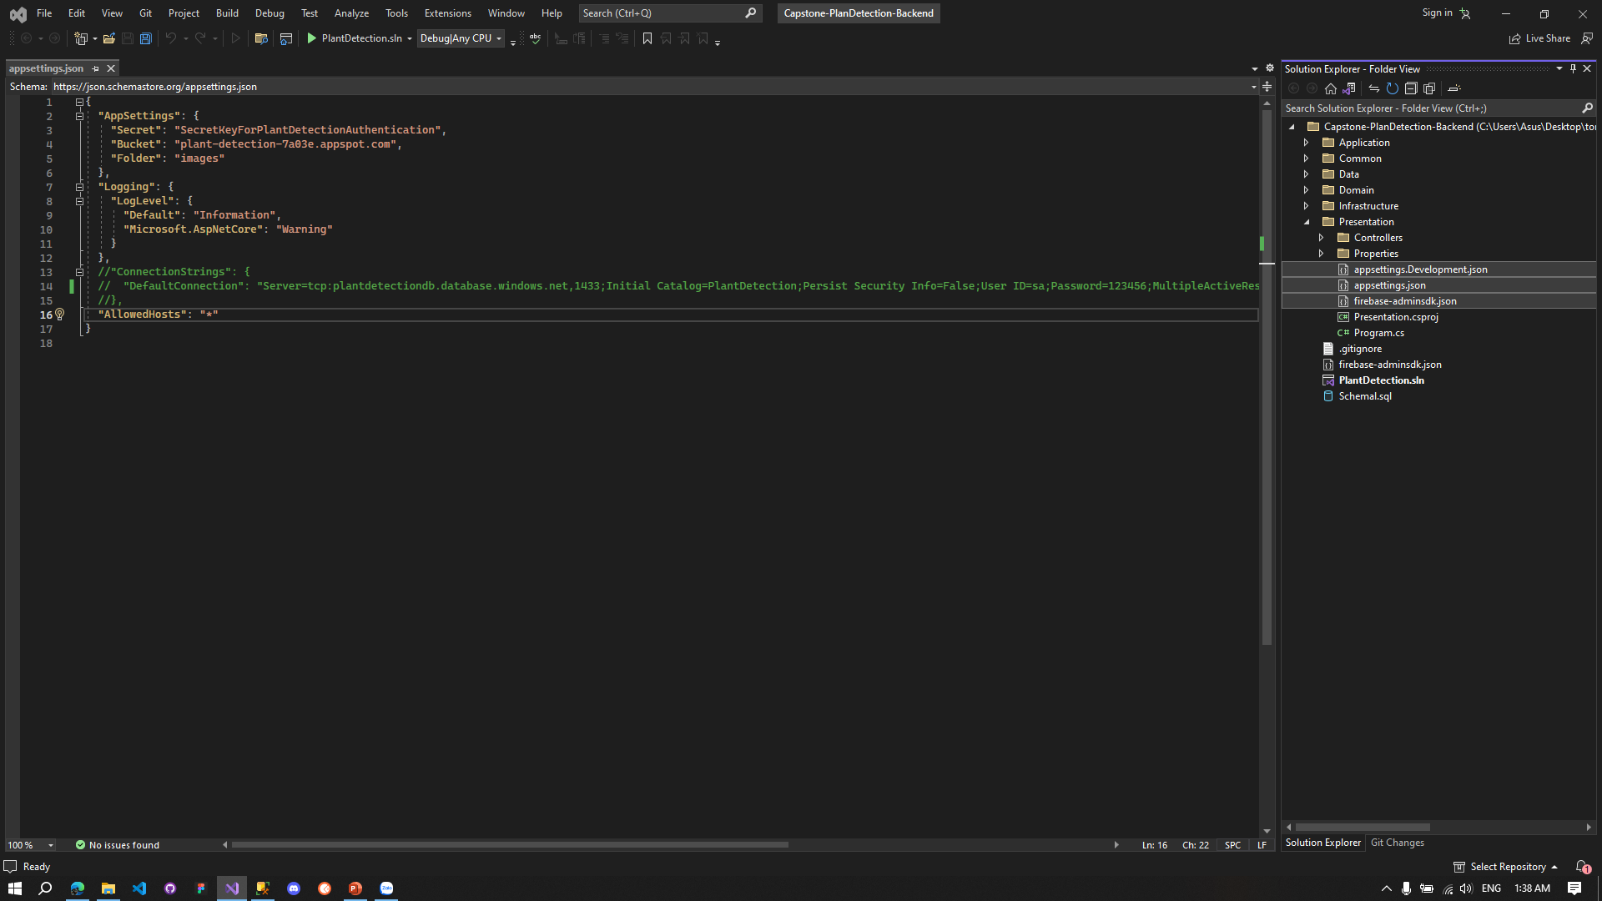

*Figure 27. Edit configuration files.*

* Double click PlantDetection.sln.

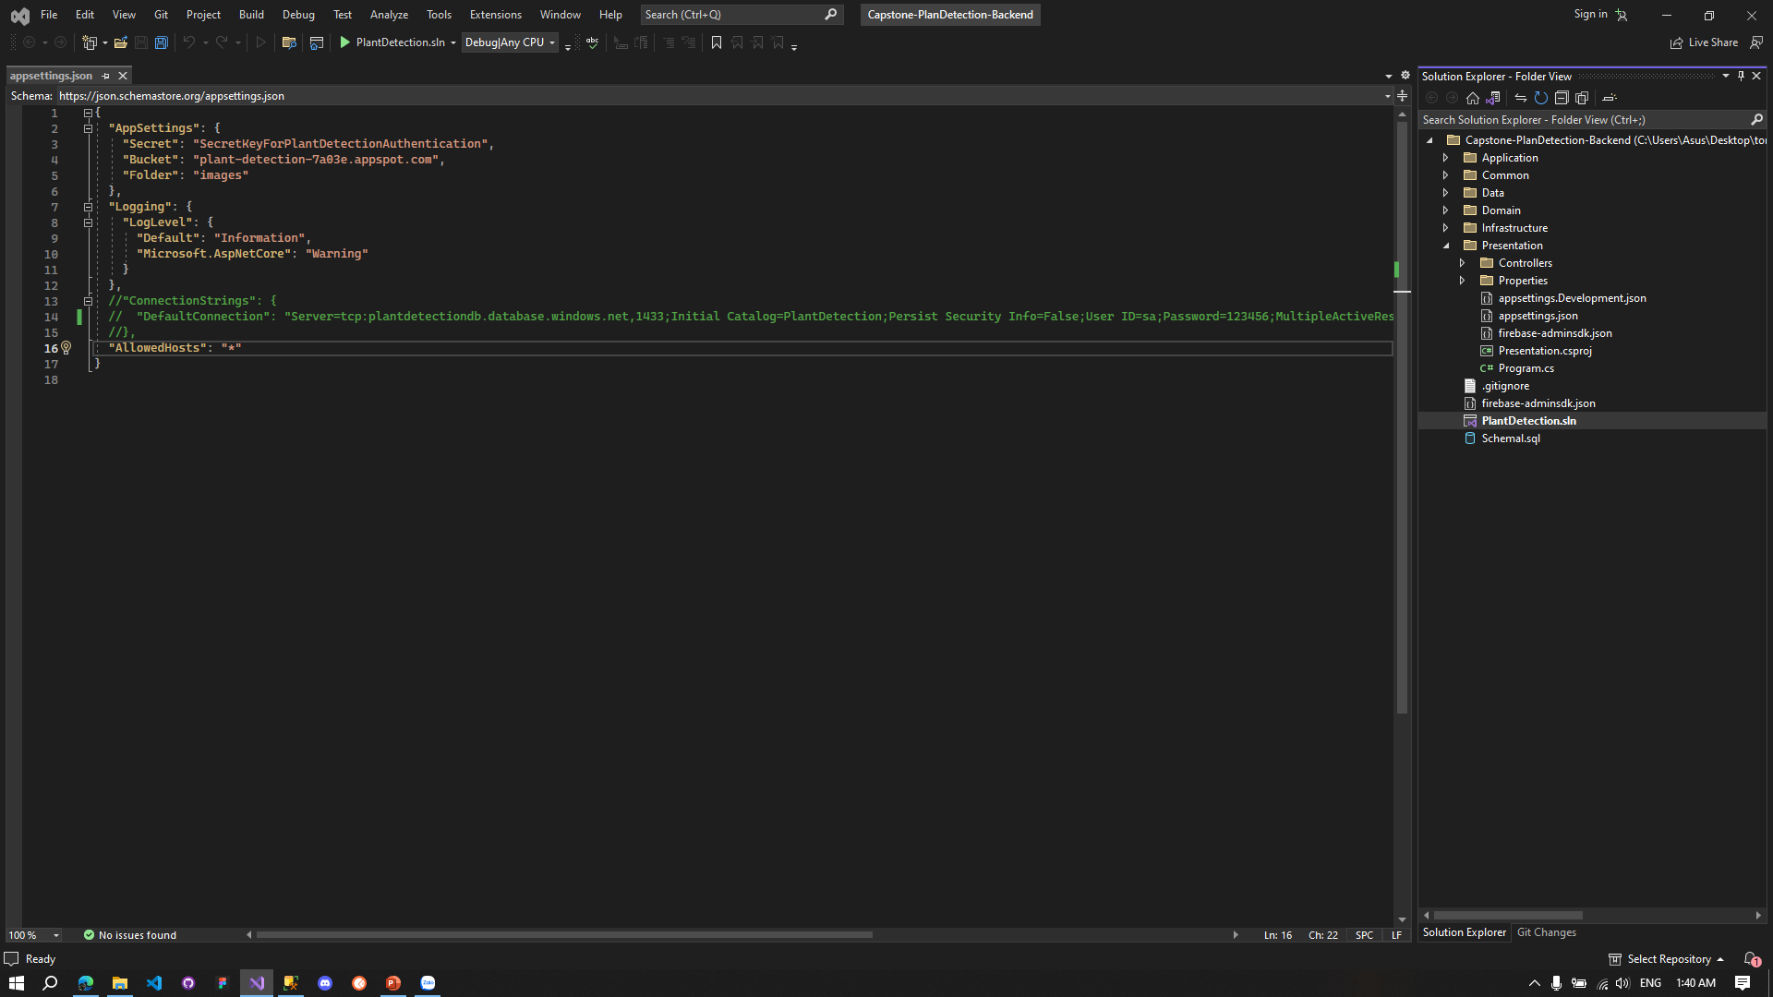

*Figure 28. Load project.*

* Run Presentation

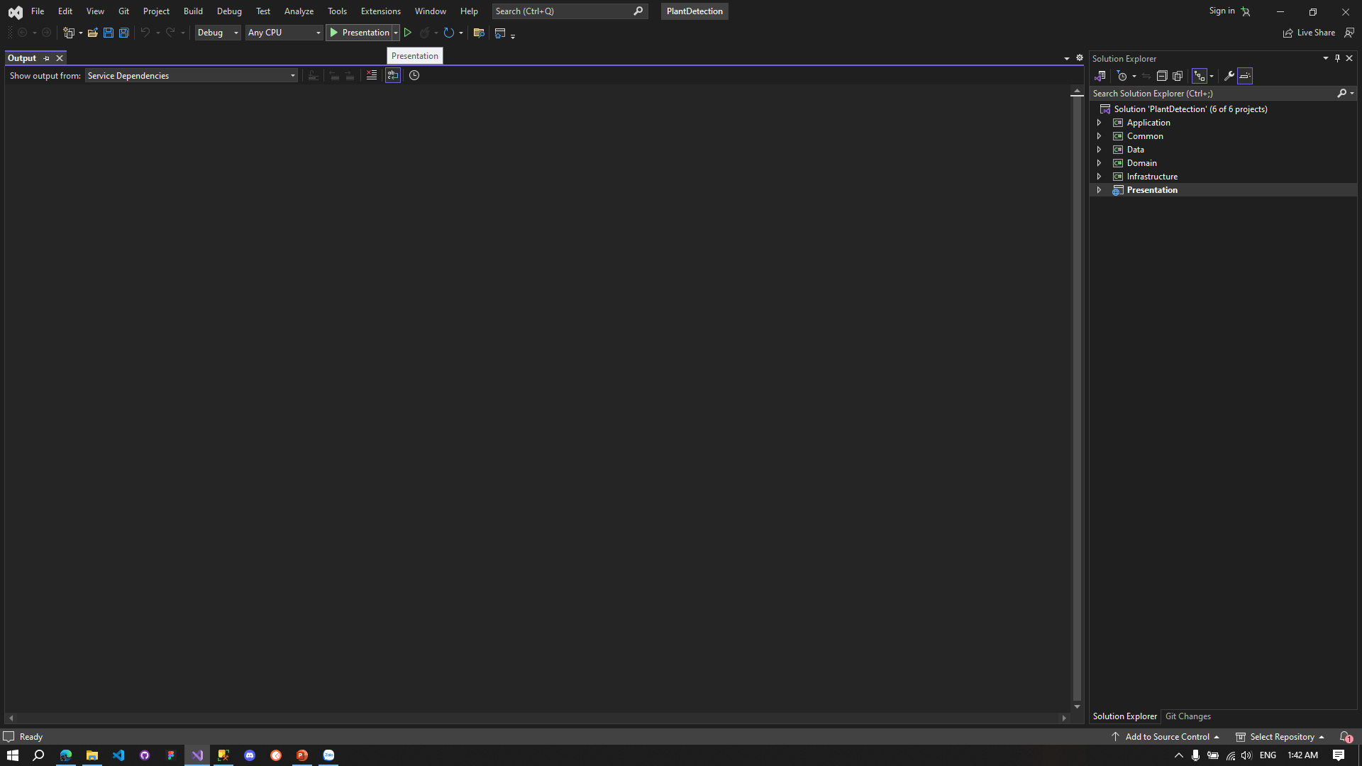

*Figure 29. Run application.*

* Application runs successfully.

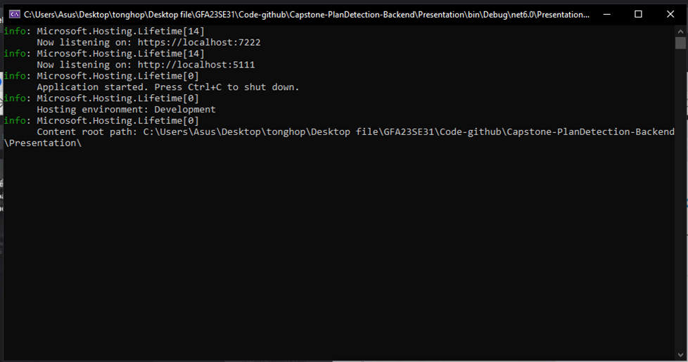

*Figure 30. Application runs successfully.*

#### 2.2.3 Run Mobile application.

* Pull code from repository<https://github.com/TungThnh/Capstone-PlantDetection-Mobile>
* Open project with Android studio, run the project in development:
* With pub **:**
* flutter pub get .
* flutter run.

## 3. User Manual

### **3.1. Overview**

**Application to identify plants and trees in school grounds** is the app utilizes advanced image recognition technology to automatically classify and identify trees from uploaded or captured.

### **3.2 User search information plant**

**Description:** User choosing the search option by name or search by available or newly captured image

**Guide steps:**

Step 1: Sign in with emai

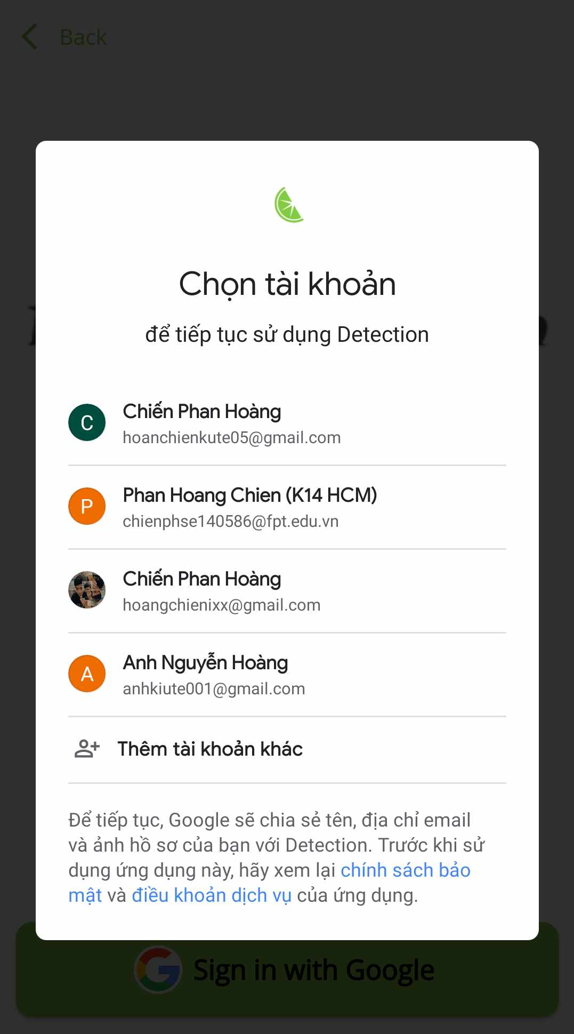

Step 2: Go to home screen on User app

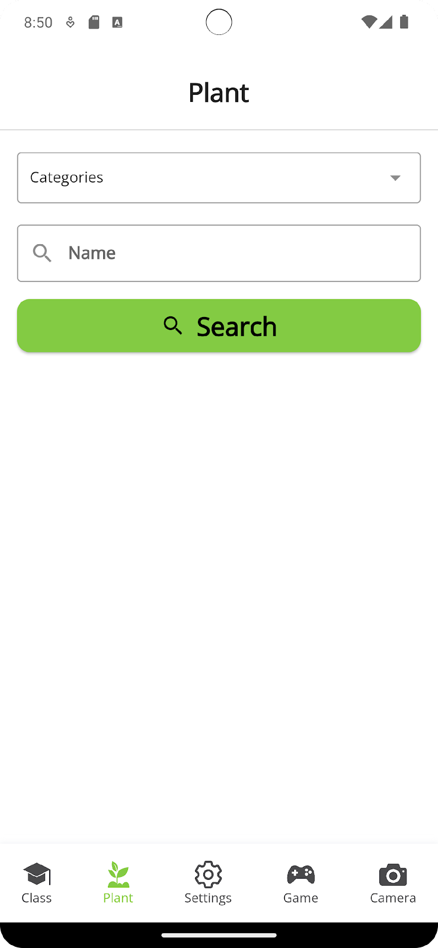

Step 3: Select the category or enter the tree name

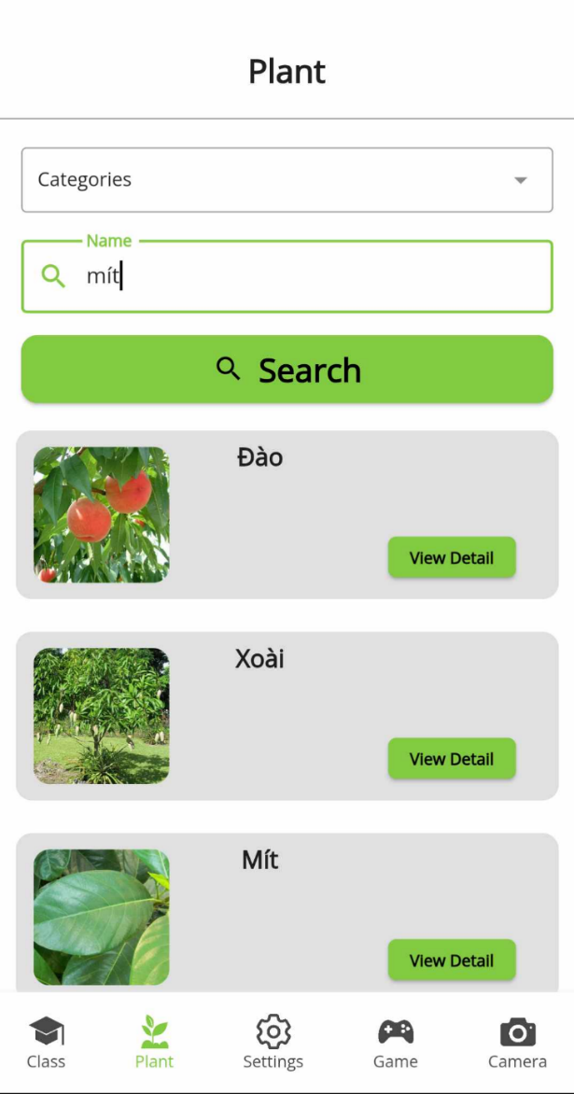

Step 4: Confirm information and search

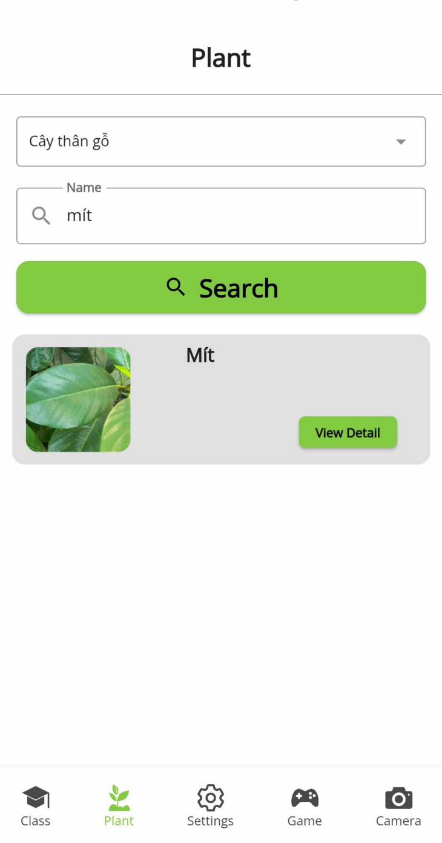

Step 5: Go to camera click icon on camera screen User app

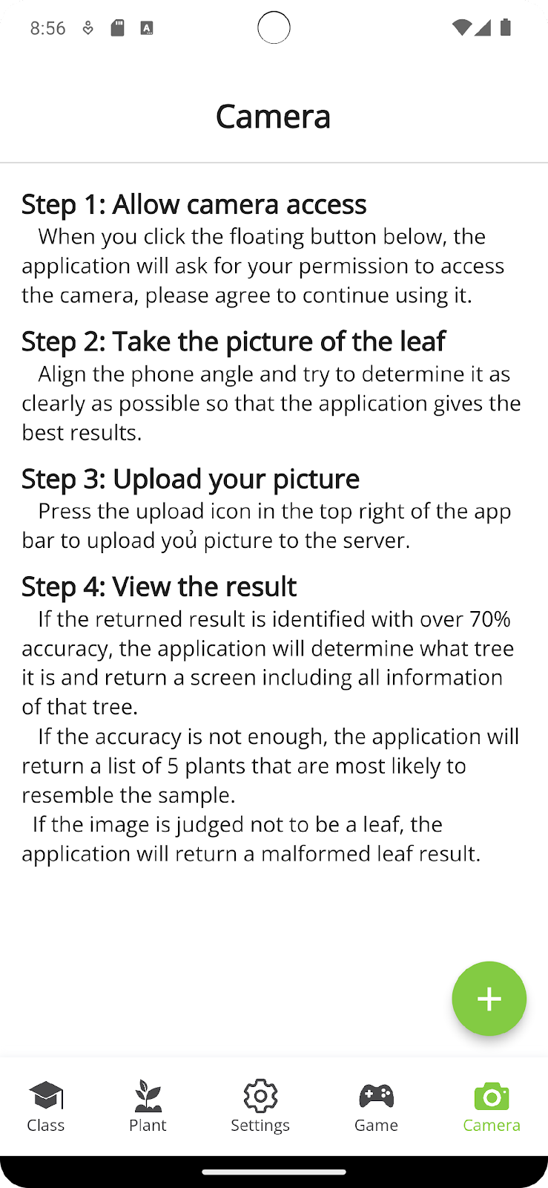

Step 6: Take photo or choose library

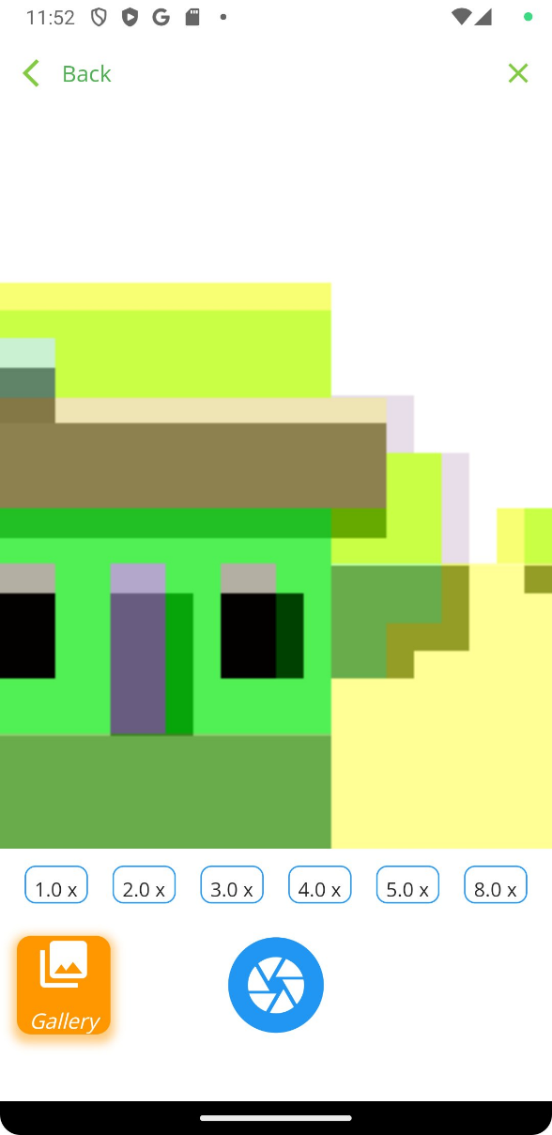

*Step 7:* Choose photo and send

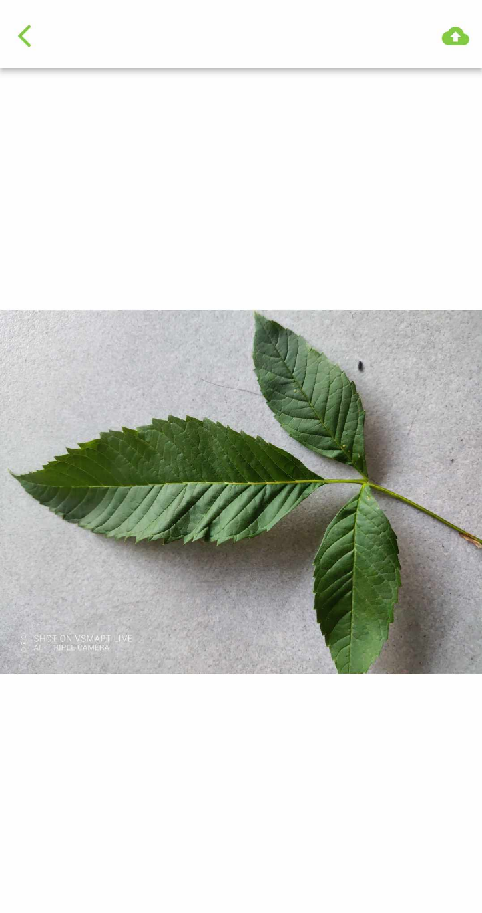

*Step 8:* Showing details plant

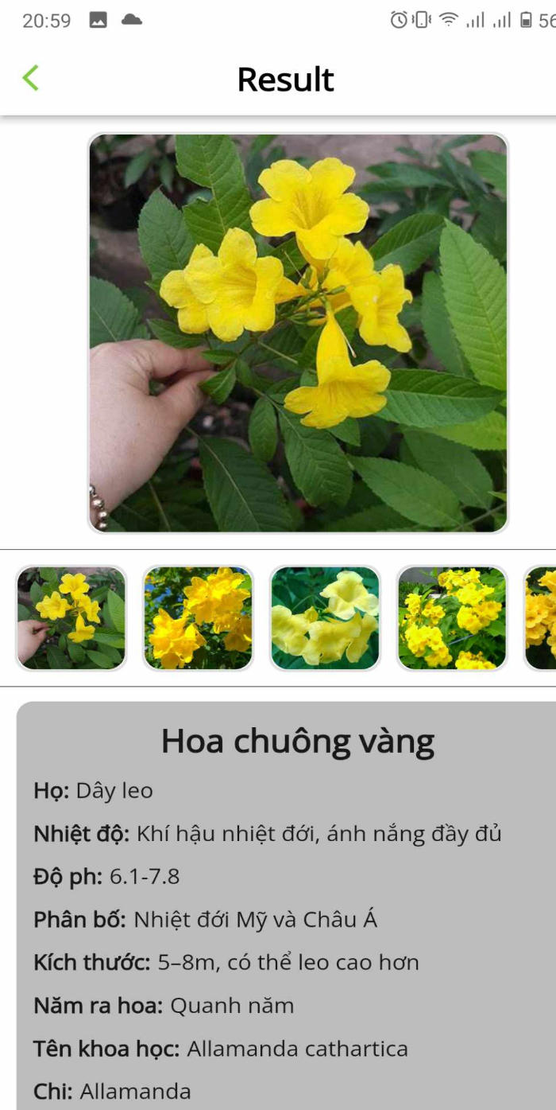

### **3.3 User join class**

**Desciption:** Users scan the QR code to enter the class to submit reports and search for specific tree information within the class.

**Guide steps:**

Step 1:Go to home screen on User app

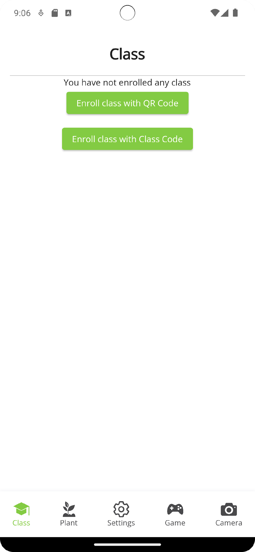

Step 2: Enroll class with QR or Class code

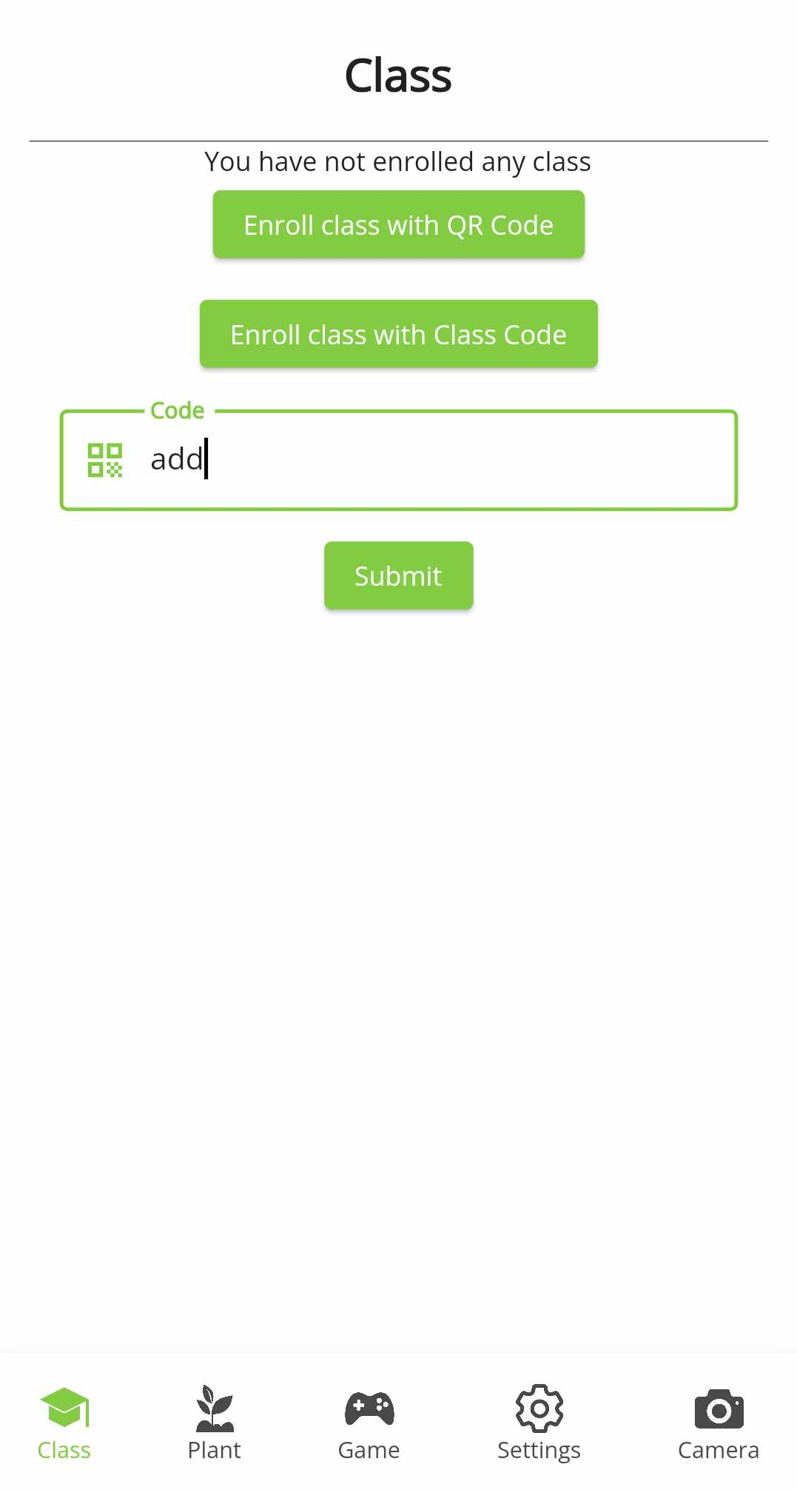

Step3: Enrolled class

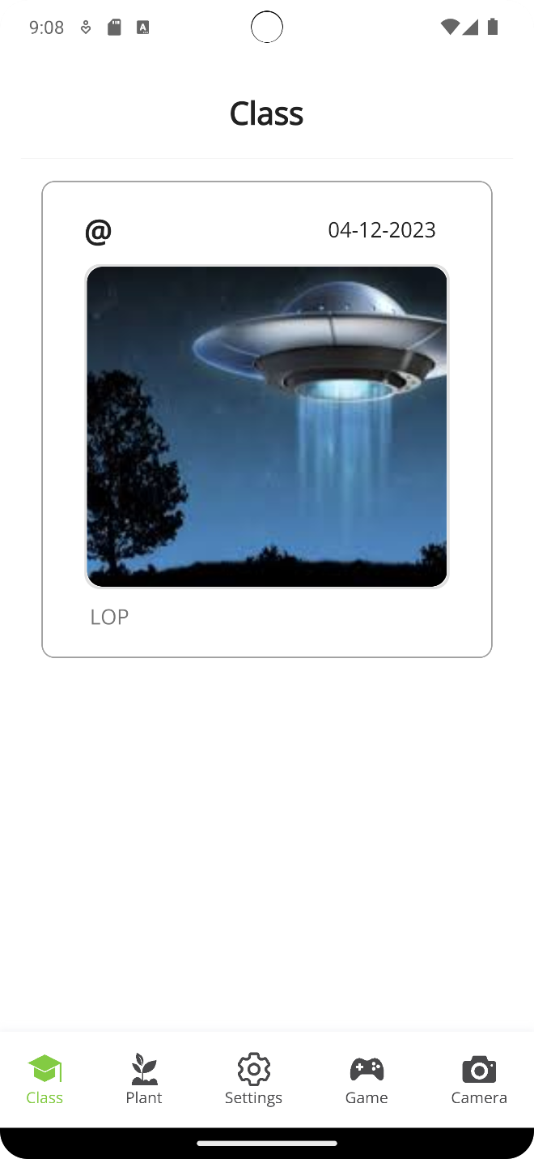

Step 4: ake photo or choose library( To use detect plan, you need to wait for the manager to load data)



Step5: Choose photo and send

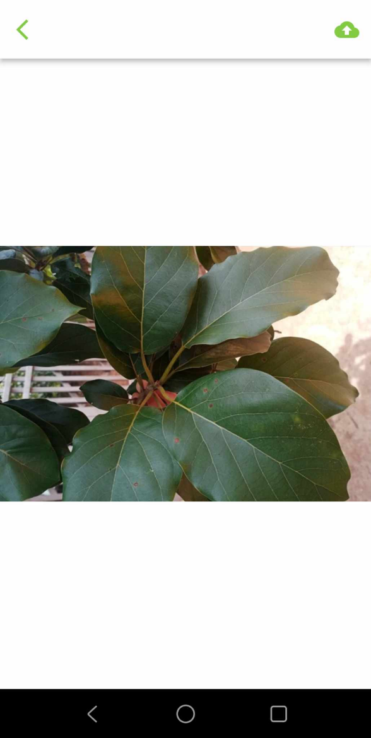

Step 6: Showing details plant

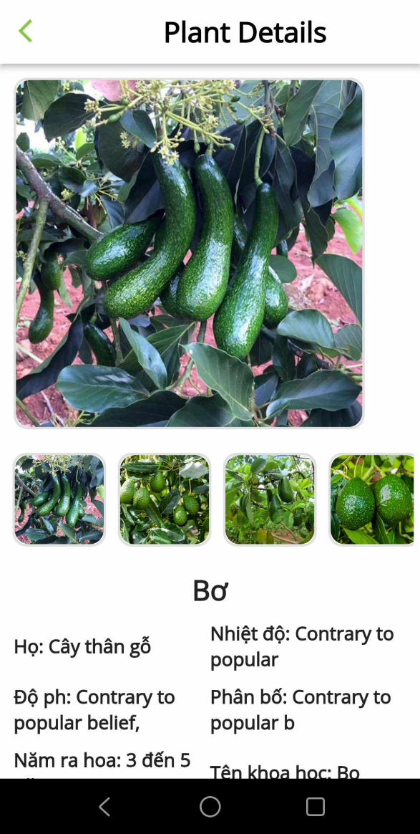

Step 7: Go back class screen Click on “Send data” button and “New +” to create report

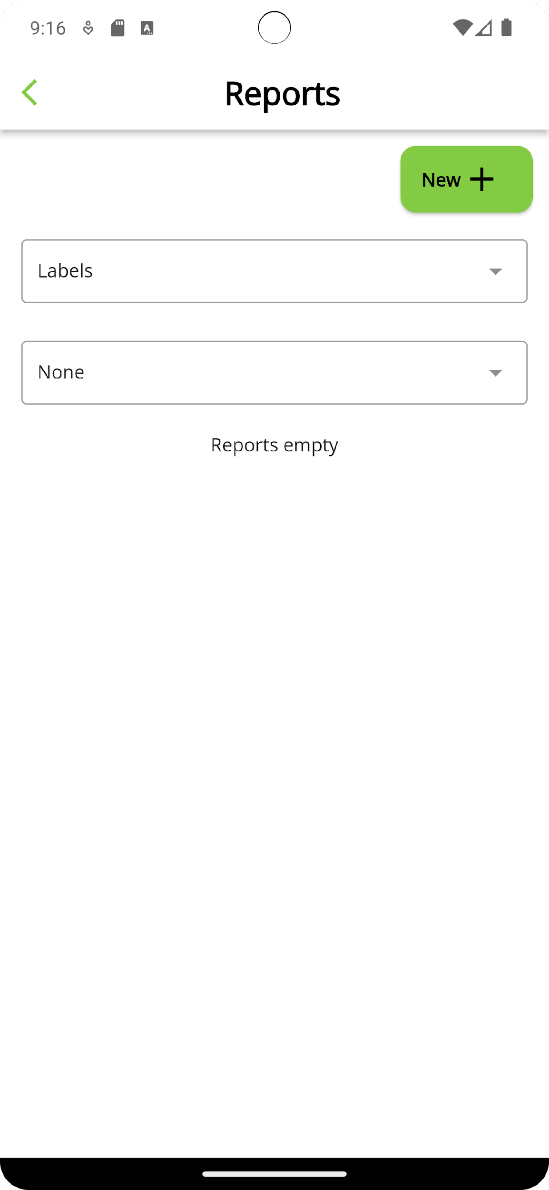

Step 8: Choose “View detail” to see more information plant report

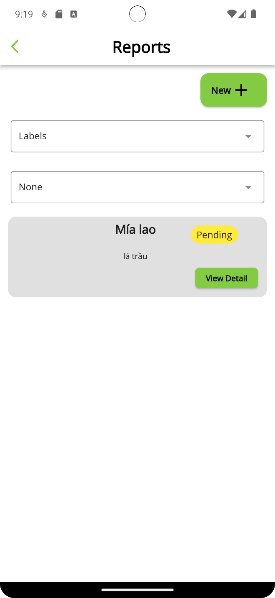

After the user submits the report, the report confirmation will be displayed on the customer's report screen and will be processed by the manager.

### **3.4 User join game**

**Description:** Quiz game was created by admin for students to play in a short time to answer questions and receive corresponding points

**Guide steps:**

Step 1: Go to home screen on User app

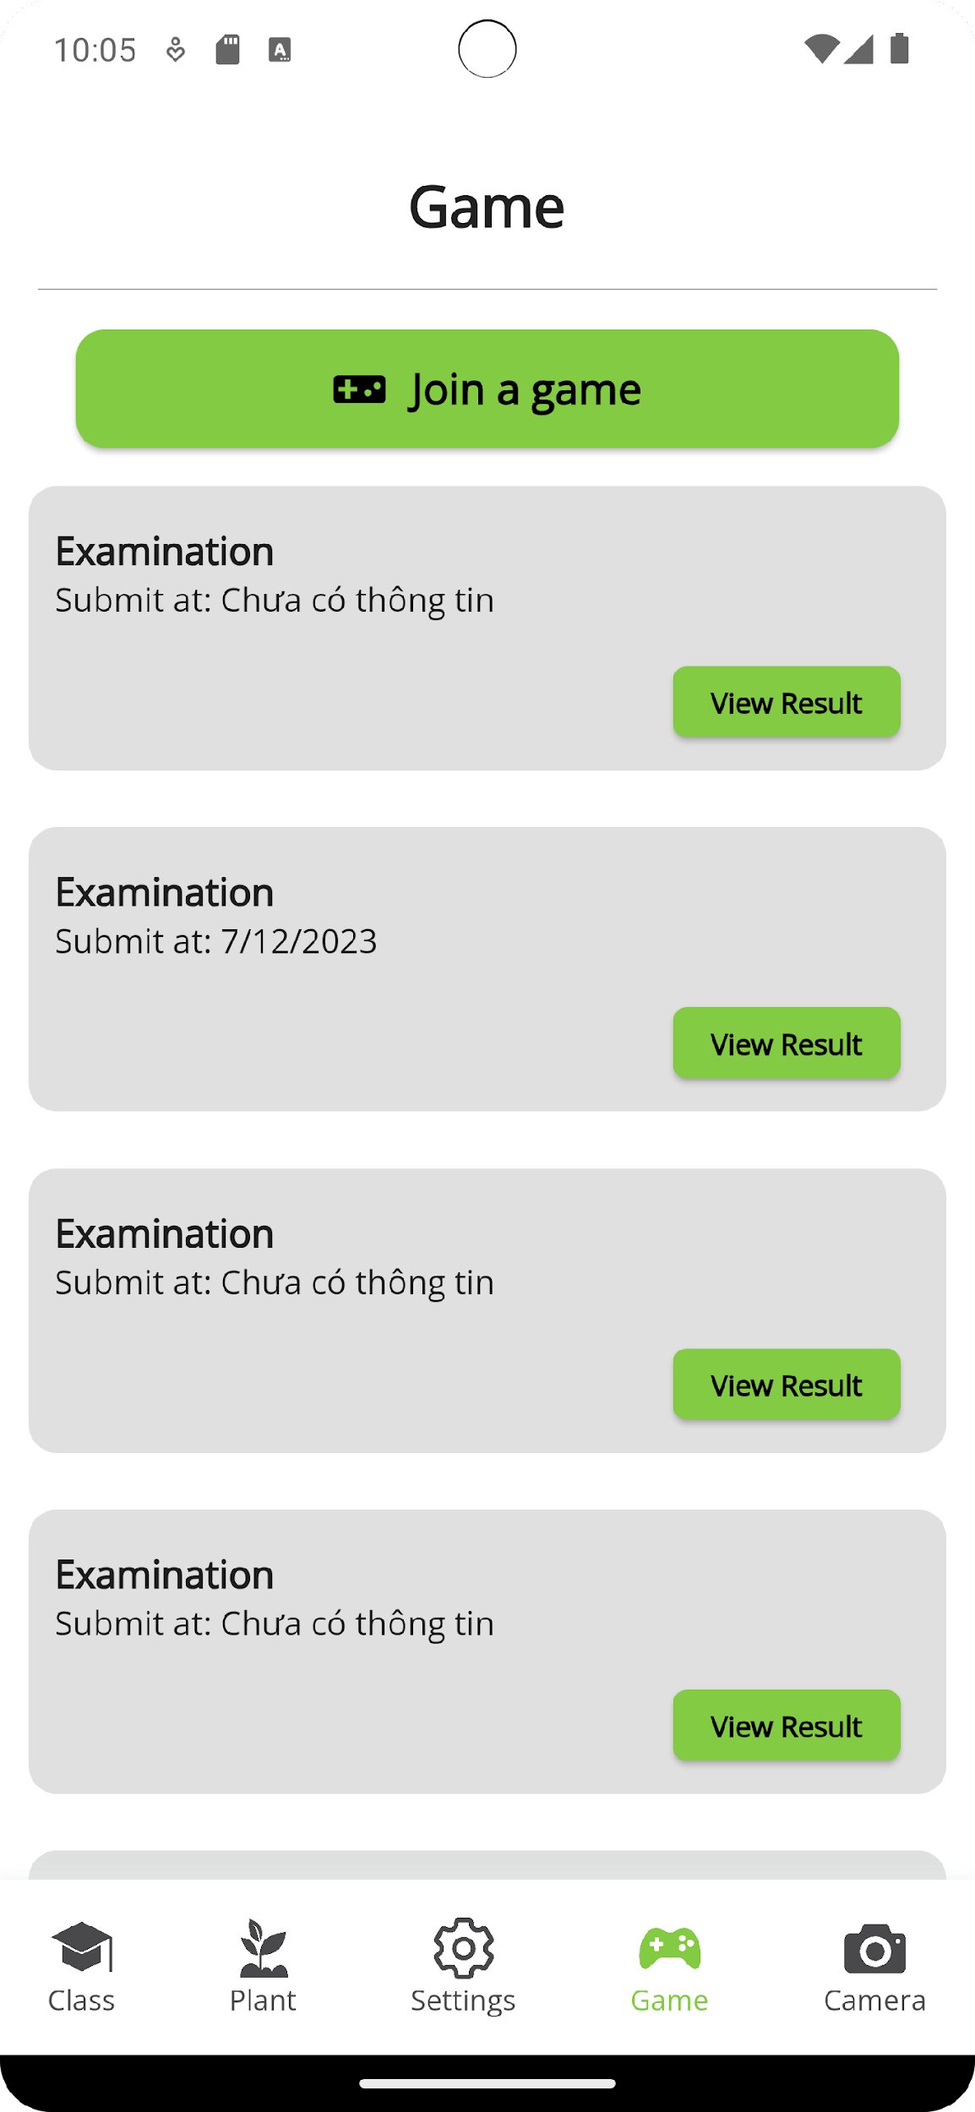

Step 2: Join game

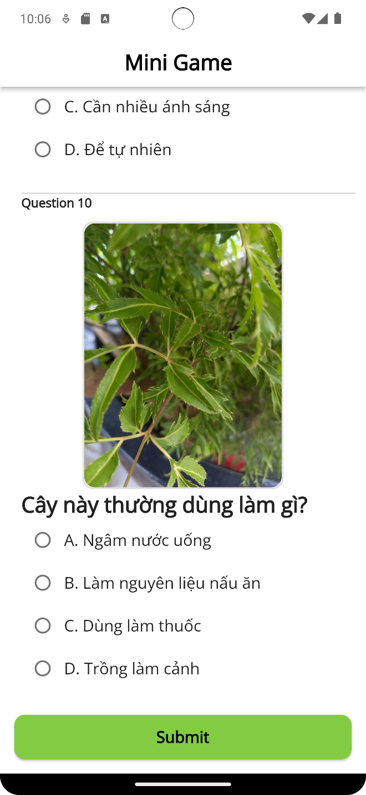

Step 3: Submit and view history

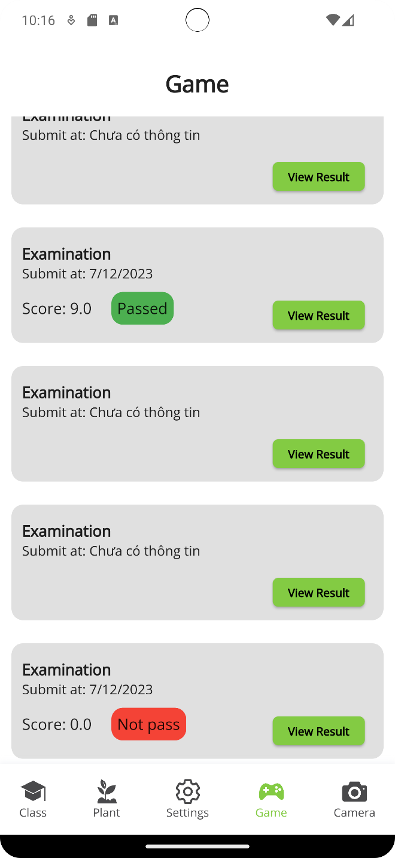

Step 4: View Result

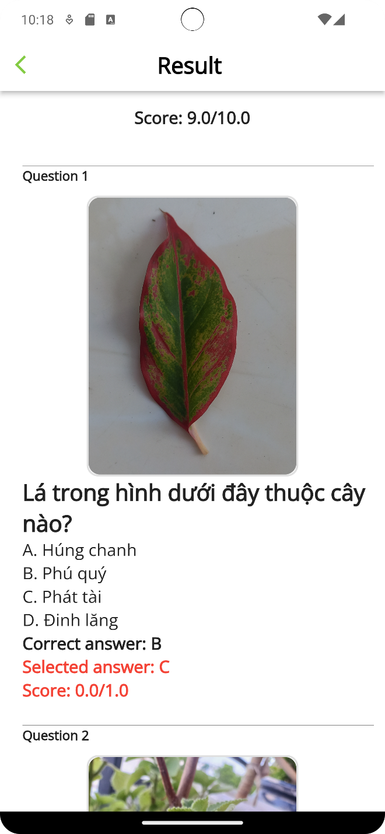

### **3.5 Admin manage class and report**

**Guide steps:**

Step1: Login

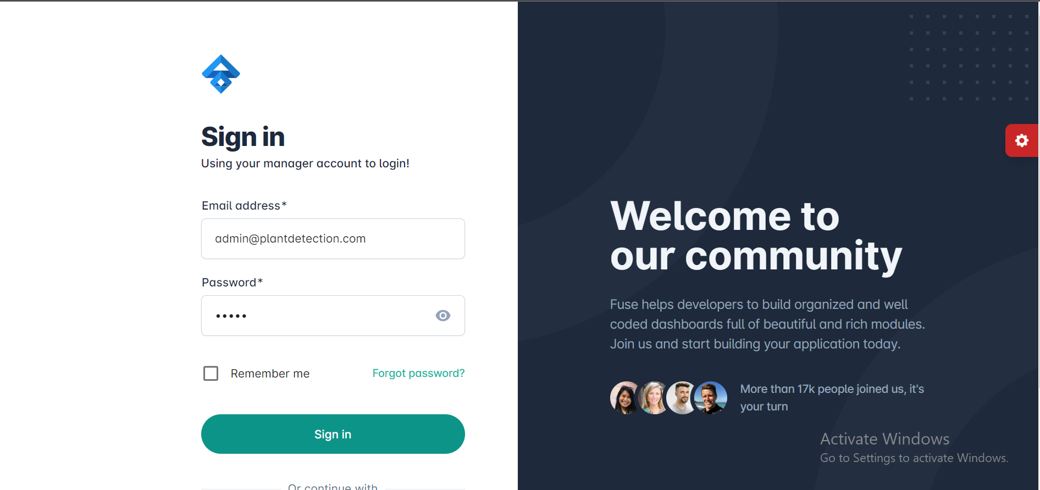

Step 2: Welcome page Admin

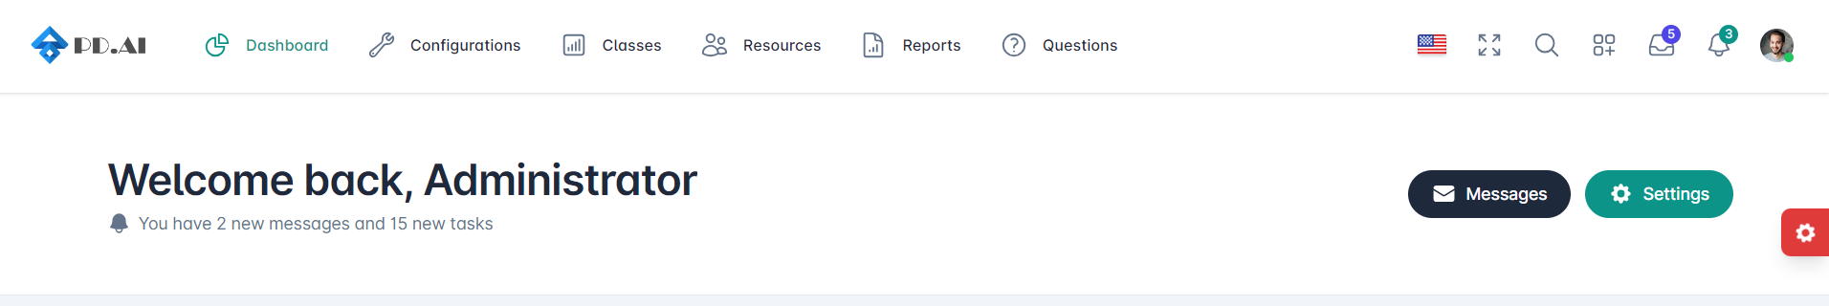

Step 3: View class list

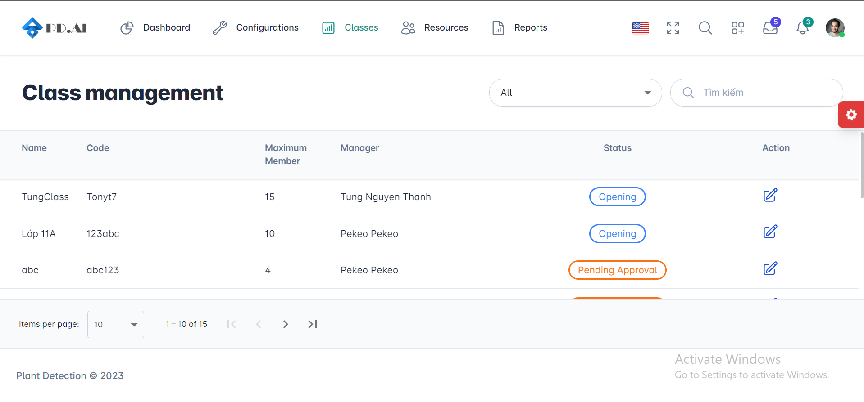

Step 4: Sort and search class

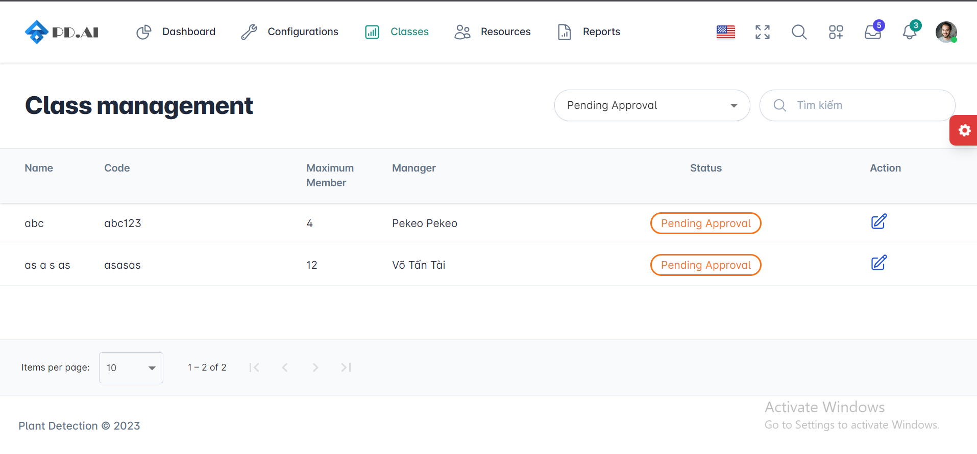

Step 5: View Report

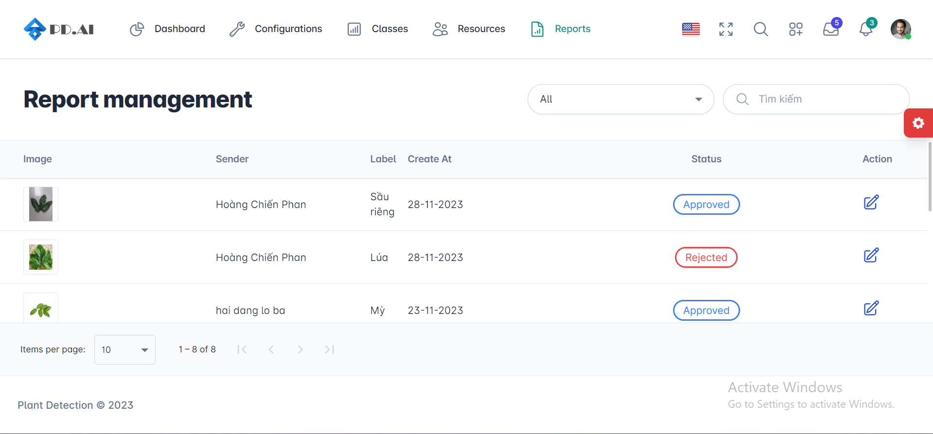

Step 6: Sort and search report

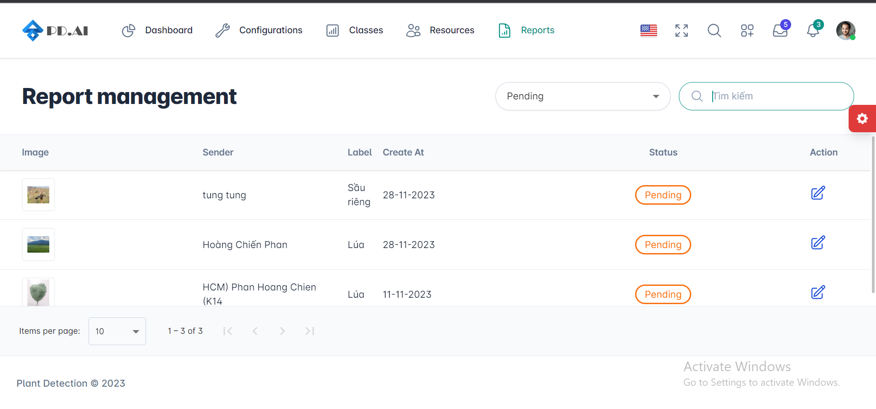

### **3.6 Admin manage plan and label**

**Guide steps:**

Step1: View plant resource

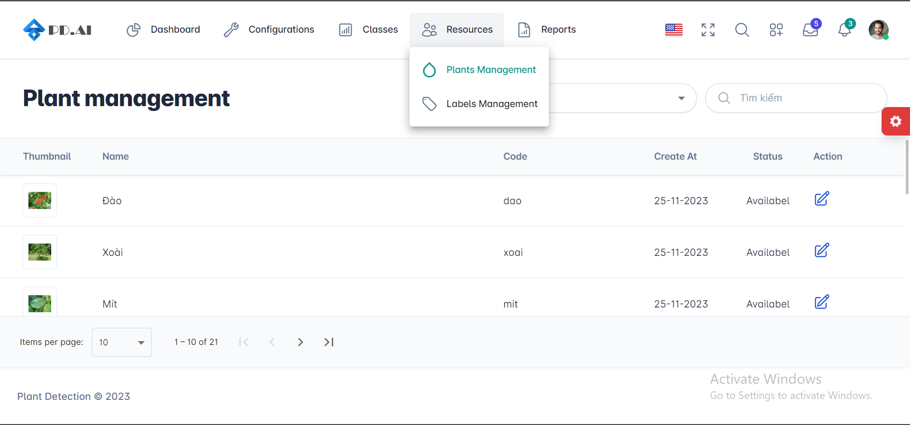

Step2: Create plant

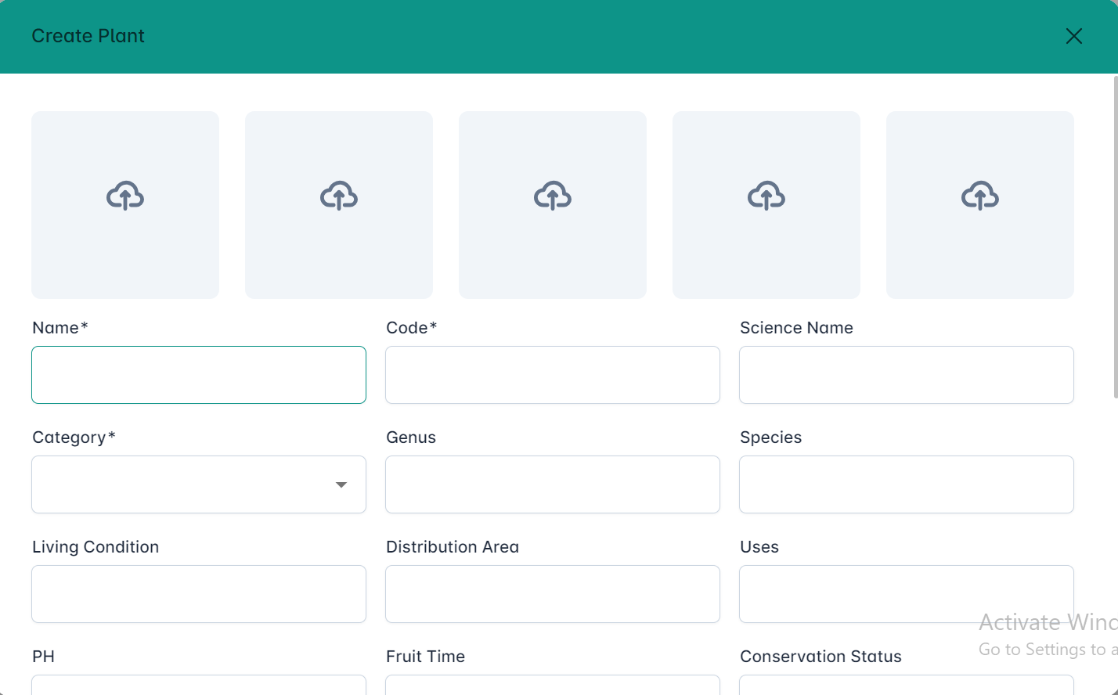

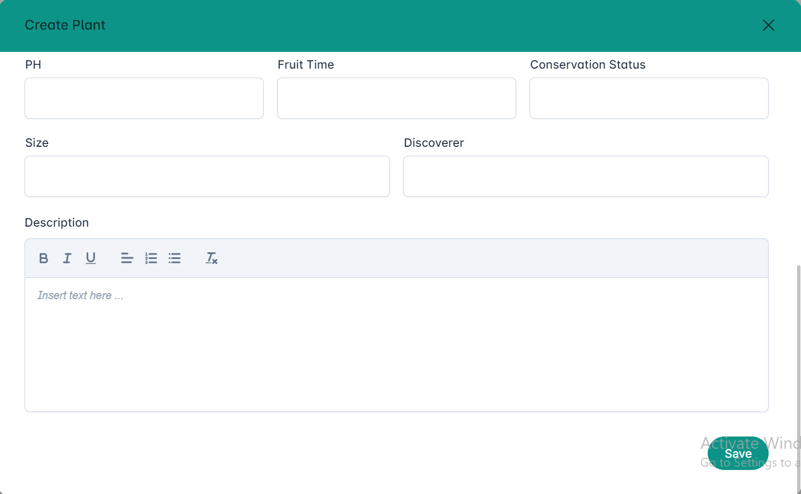

Step3: View plant detail

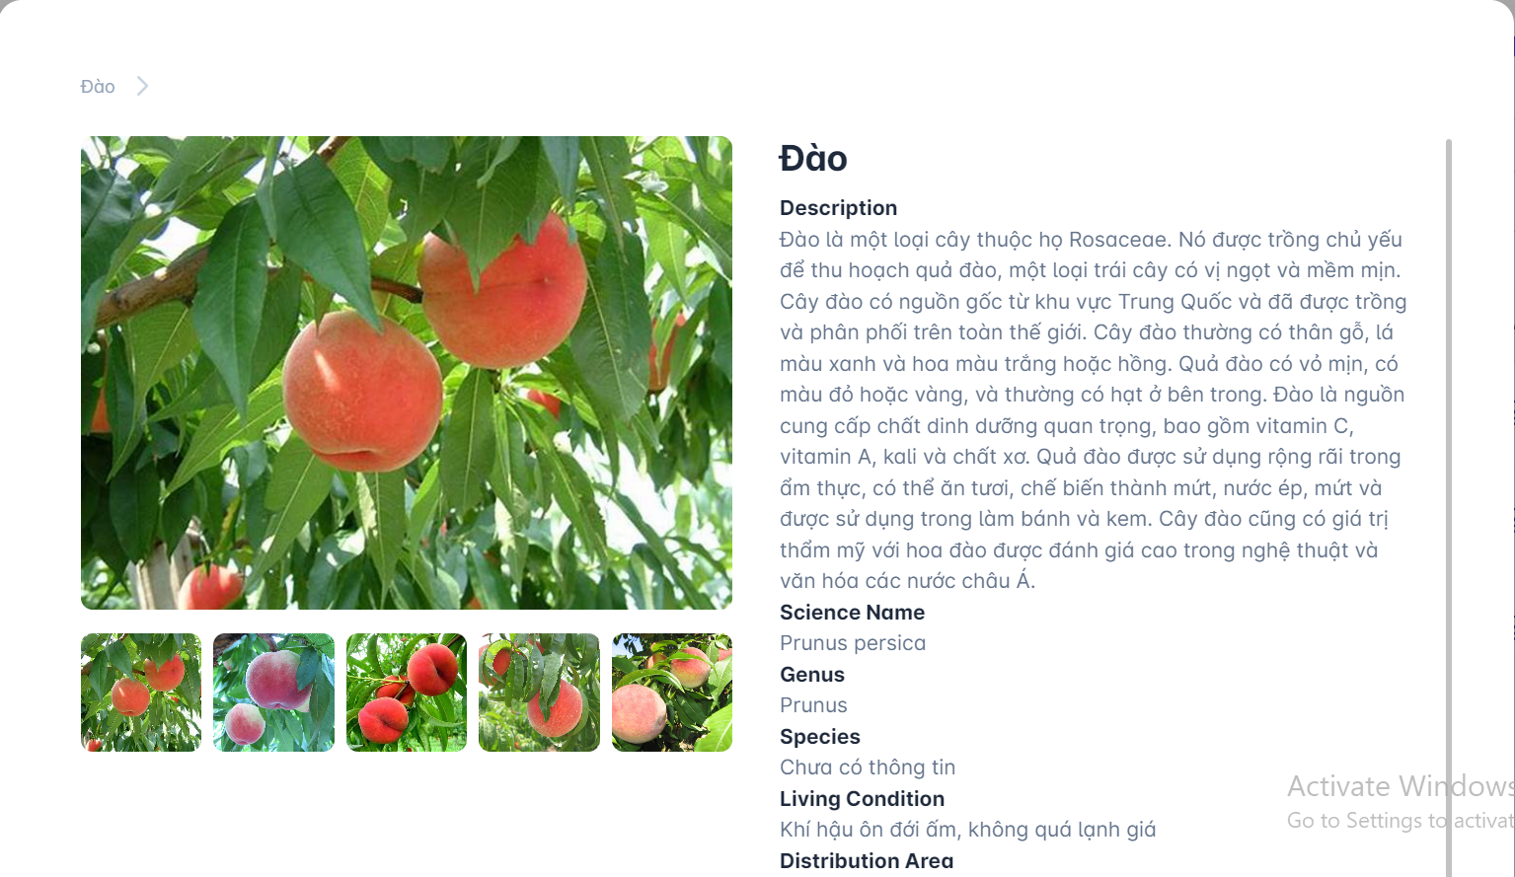

Step 4: Sort and search plant resource

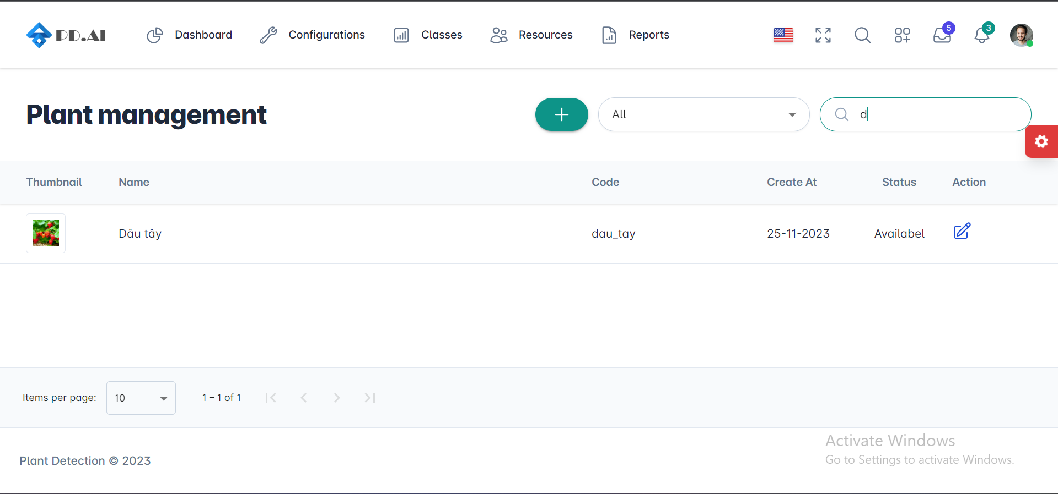

Step 5: View label resource

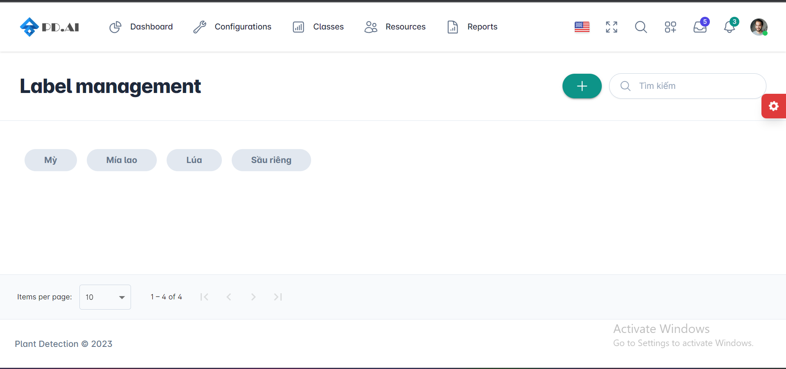

Step 6: Add label

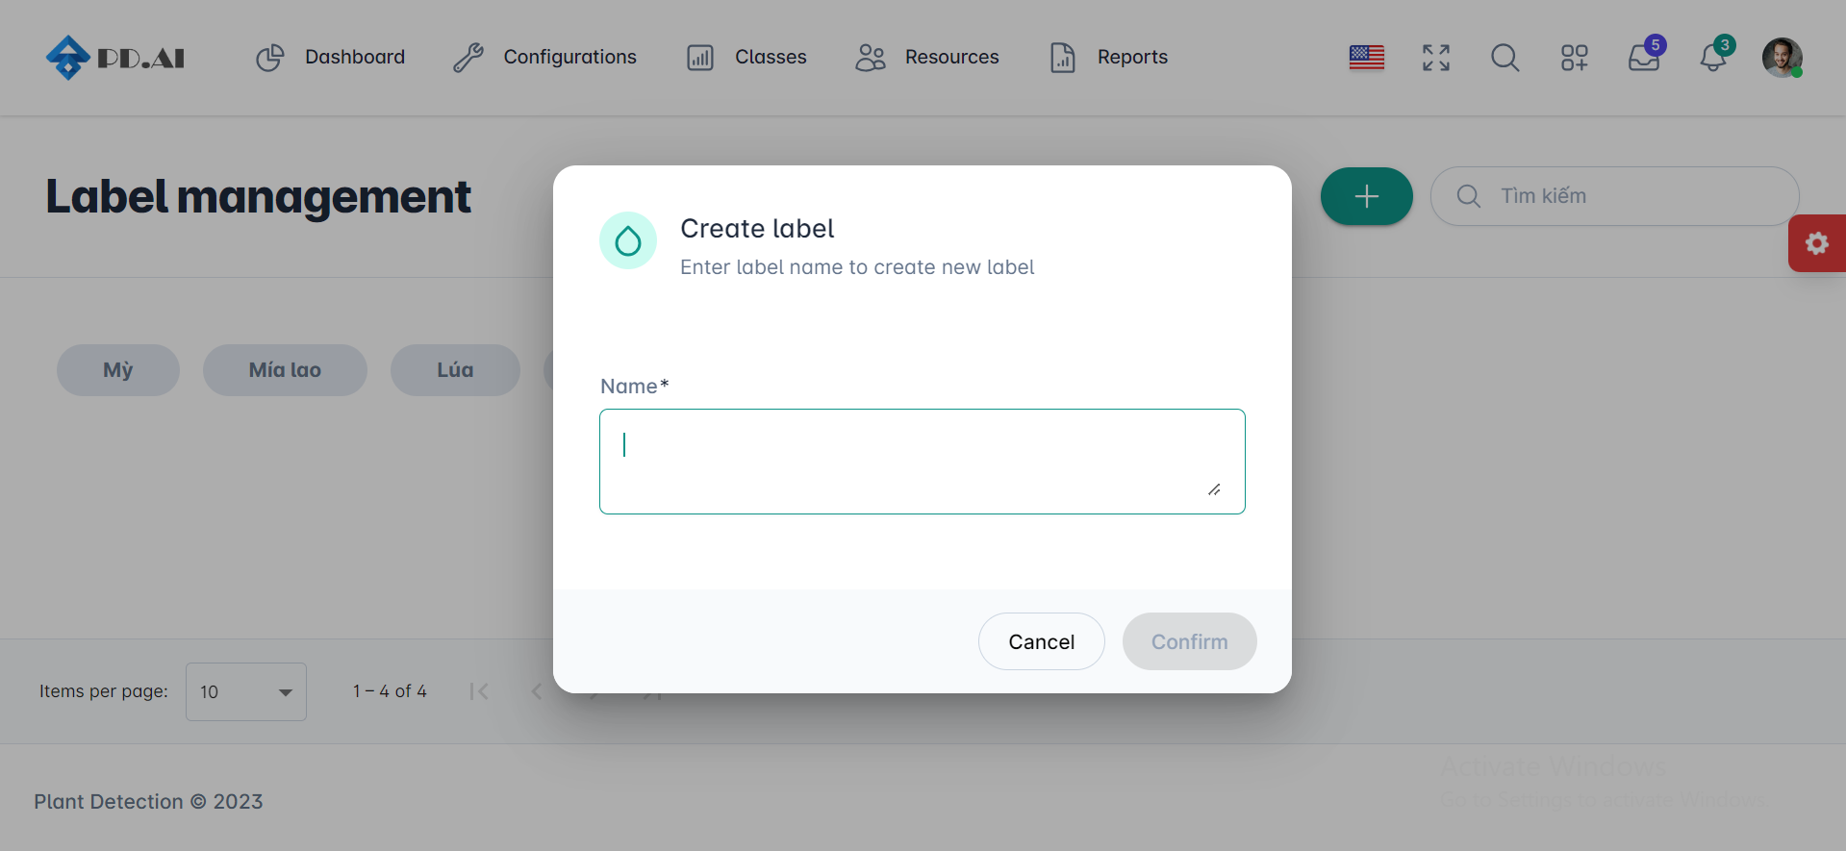

### **3.7 Admin manage quiz game**

**Guide steps:**

Step1: View Questions manage

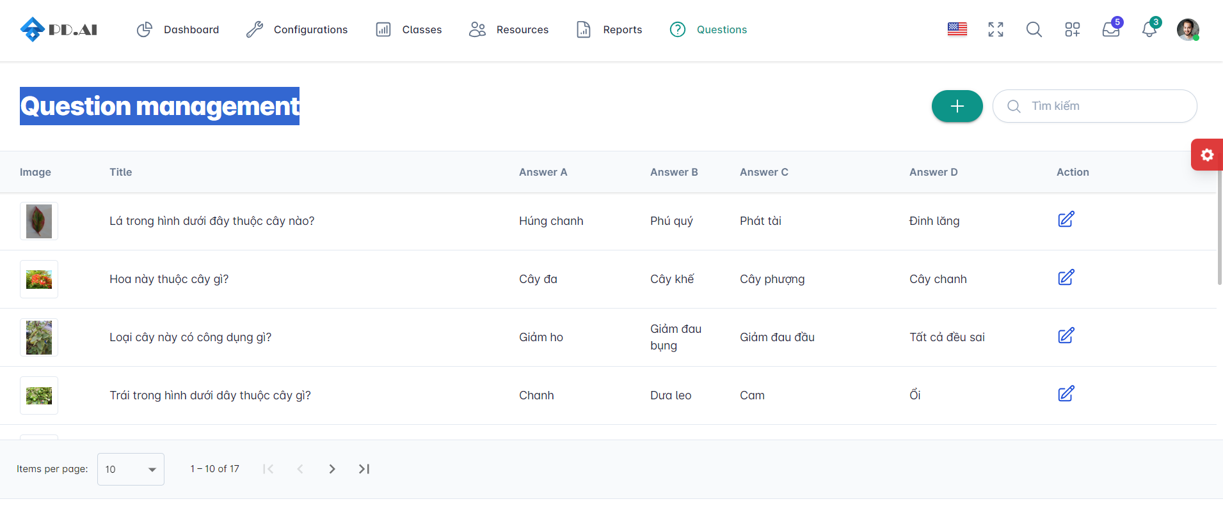

Step1: Create question

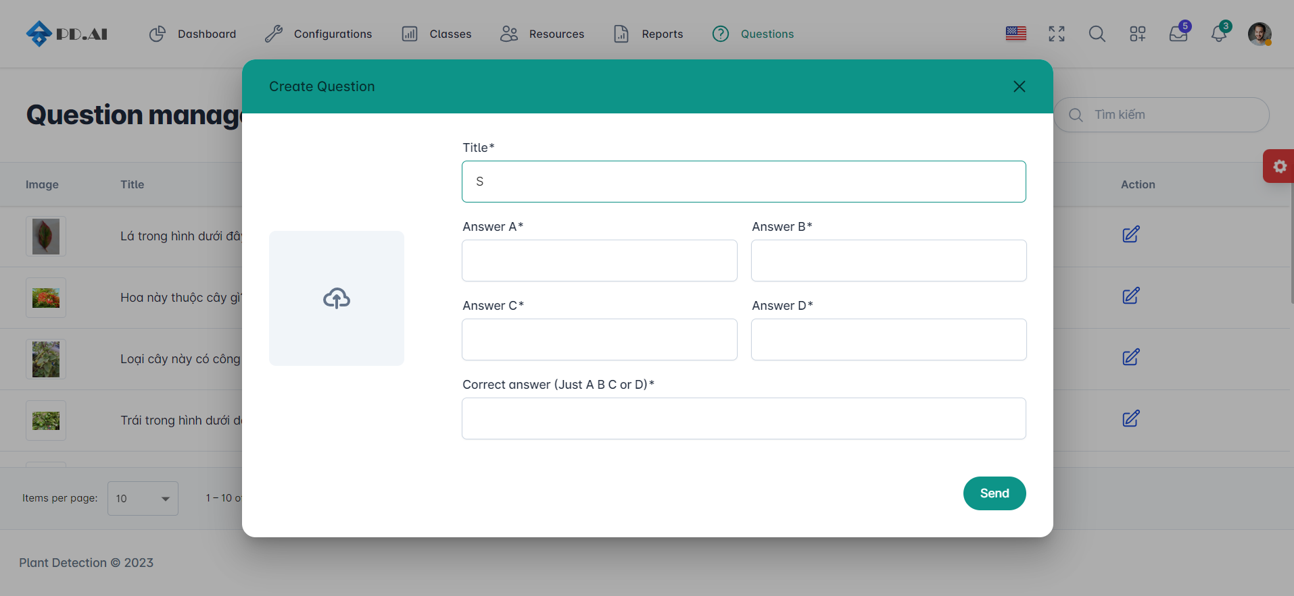

### **3.8 Manager class**

**Guide steps:**

Step1: Sign in

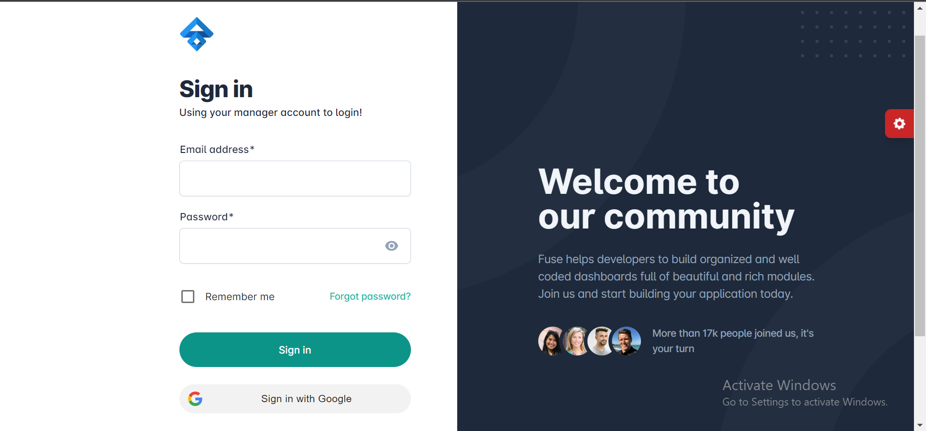

Step2: Sign in with google



Step 3: Welcome page

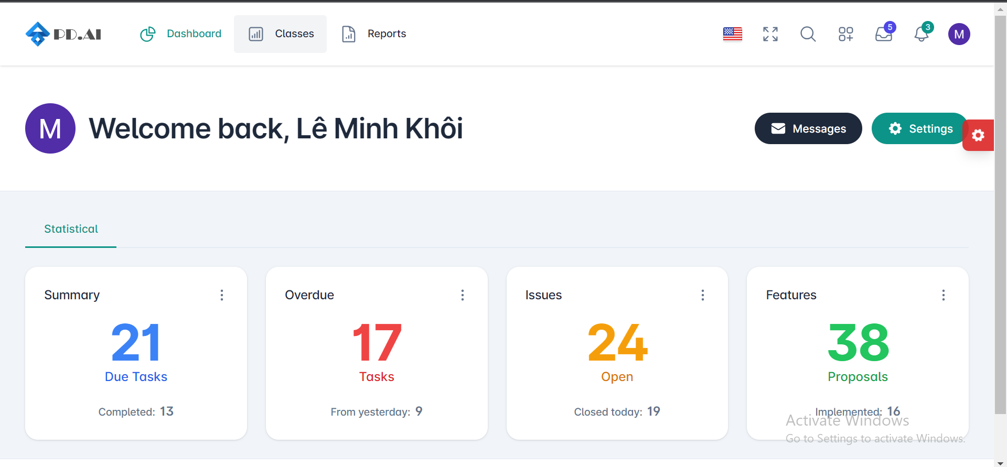

Step 4: View class

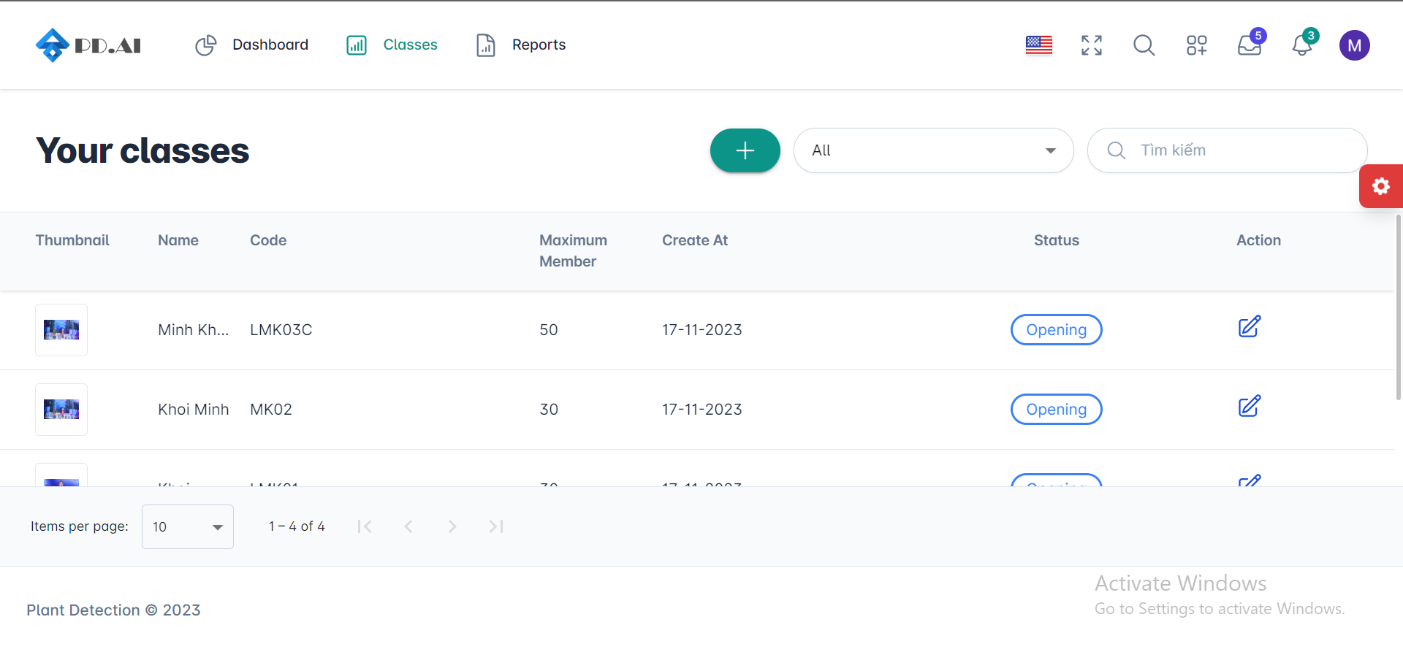

Step 5: Sort and search class

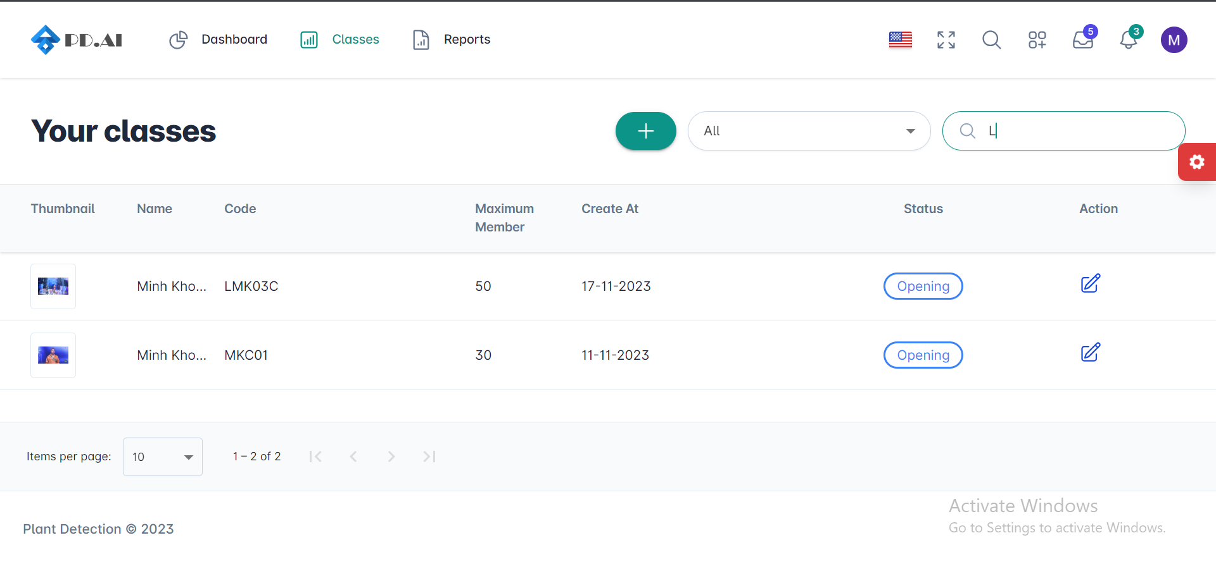

Step 6: Create class

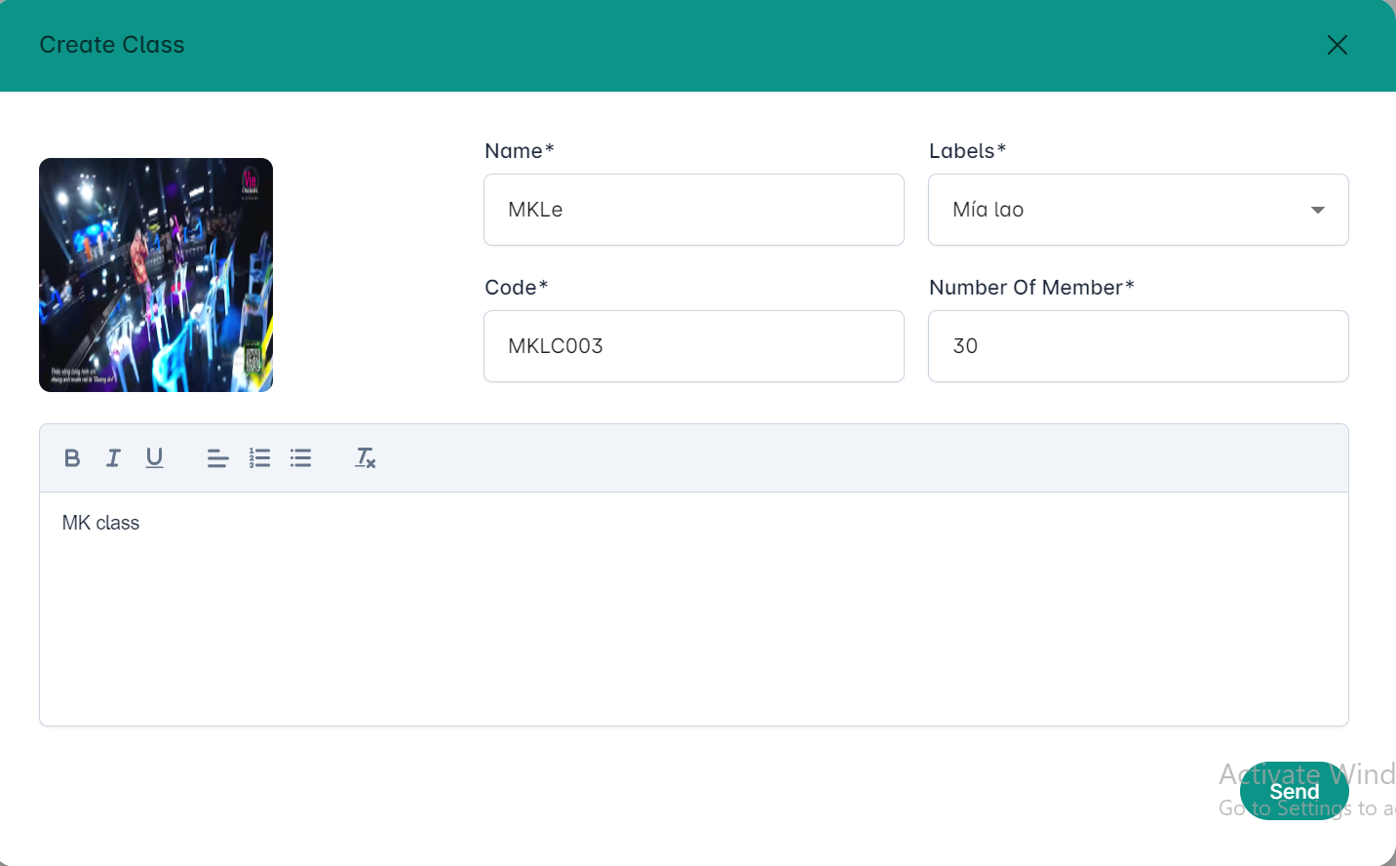

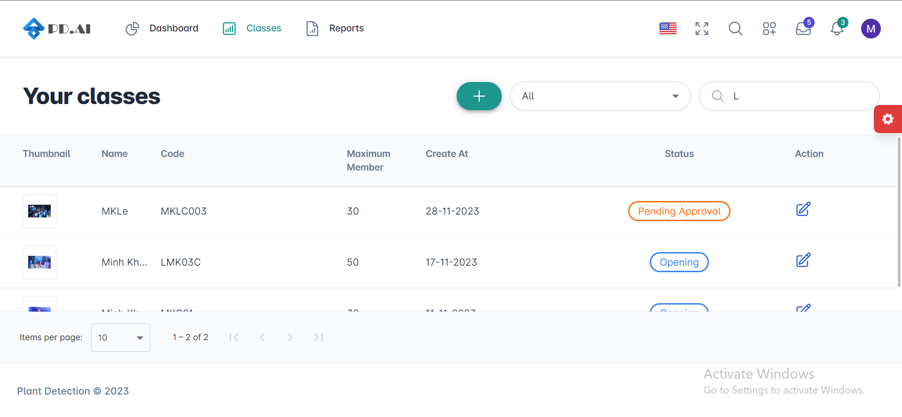

Step 7: View class detail

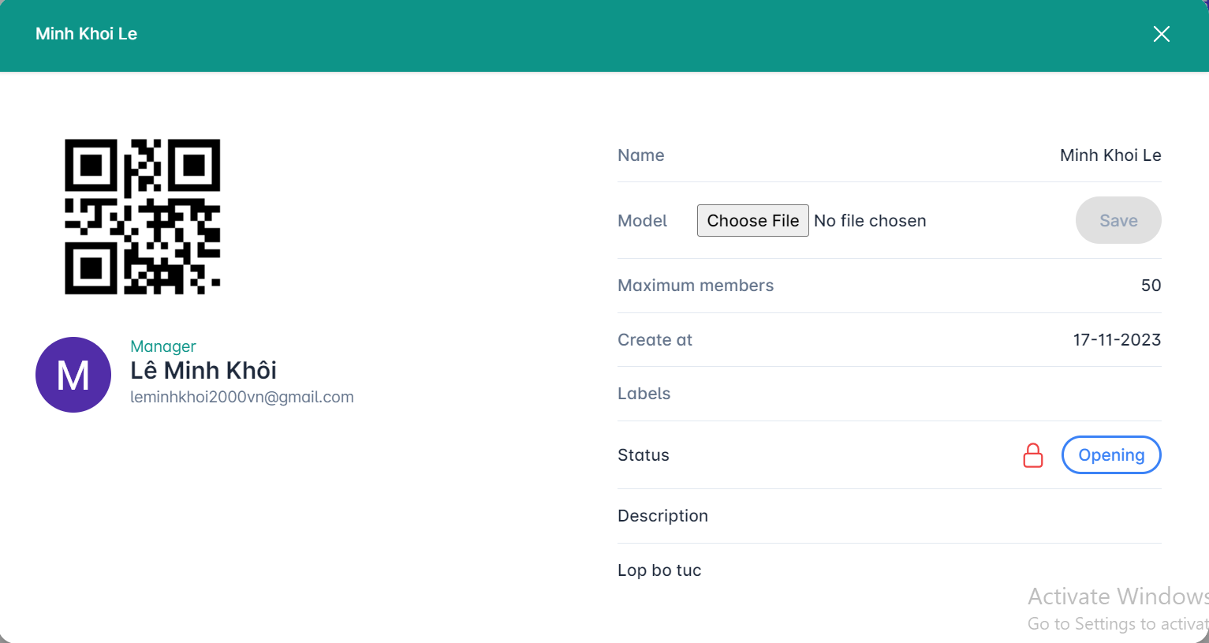

Step 8: Change class status (Open or Close)

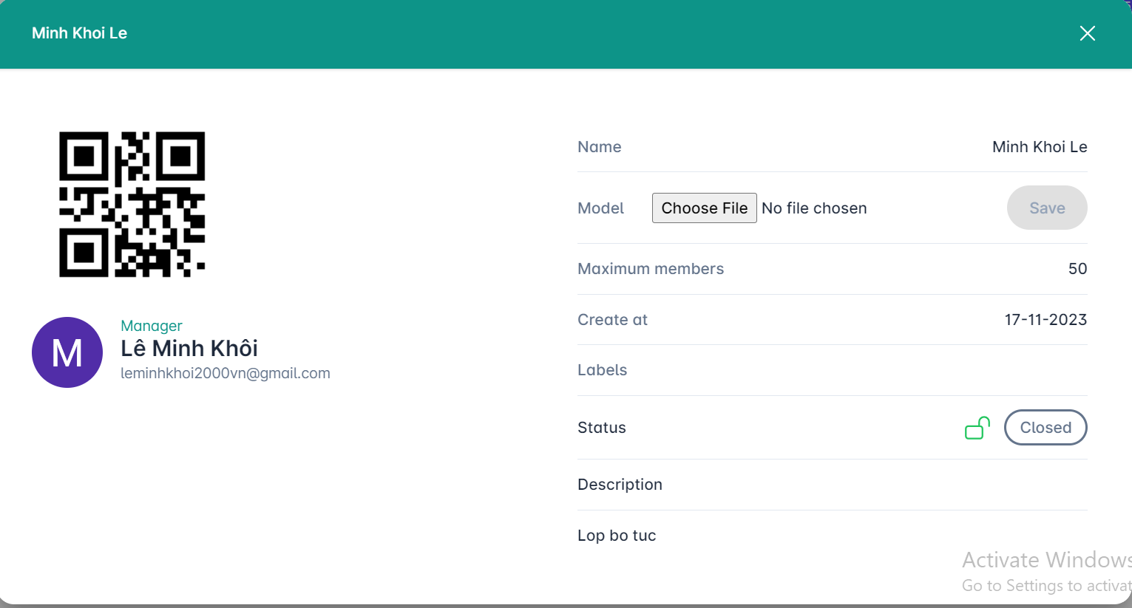

### **3.8.1 Manager reports**

Step 1: Manage status reports

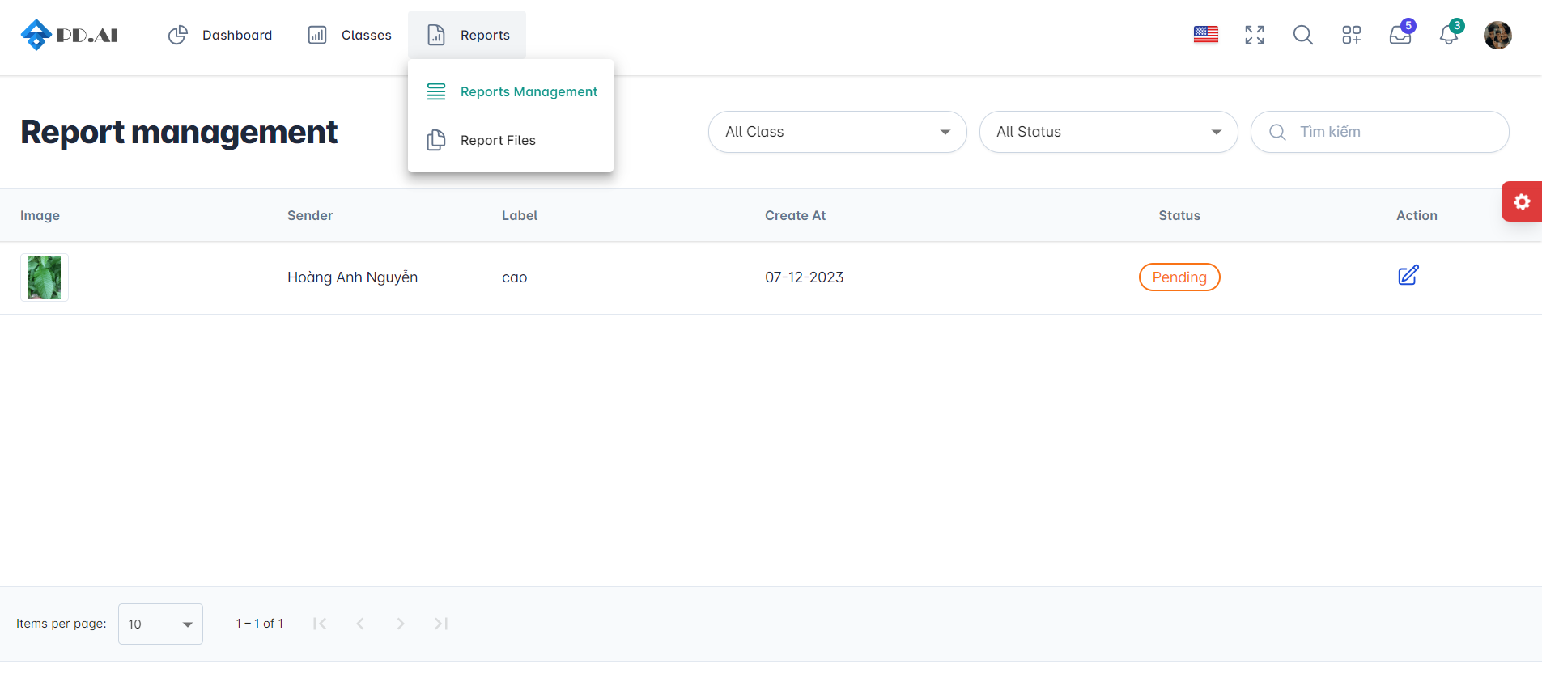

Step 2: Choose status

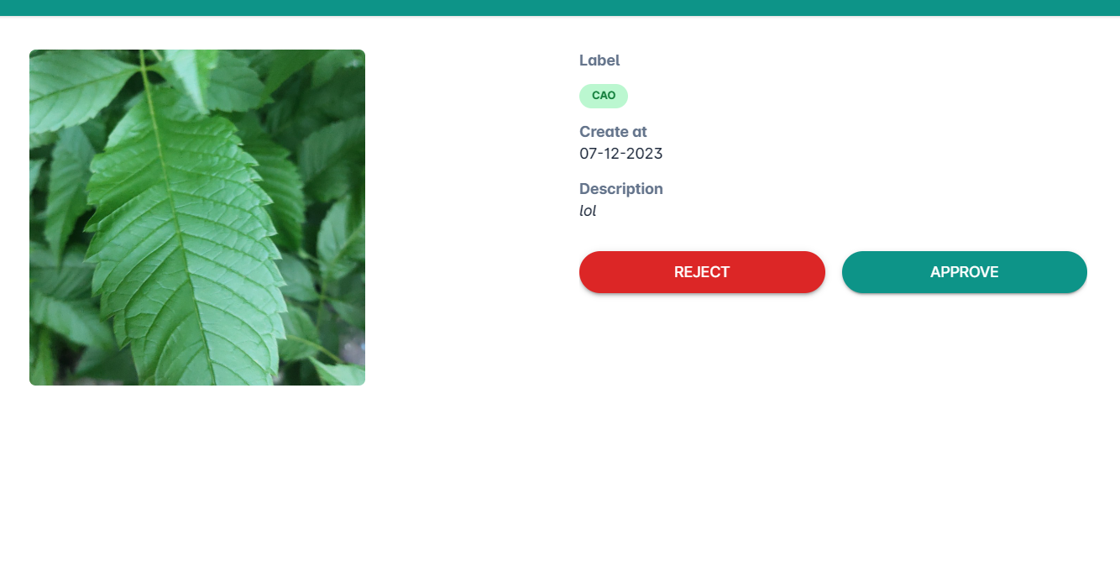

Step 3: Update success

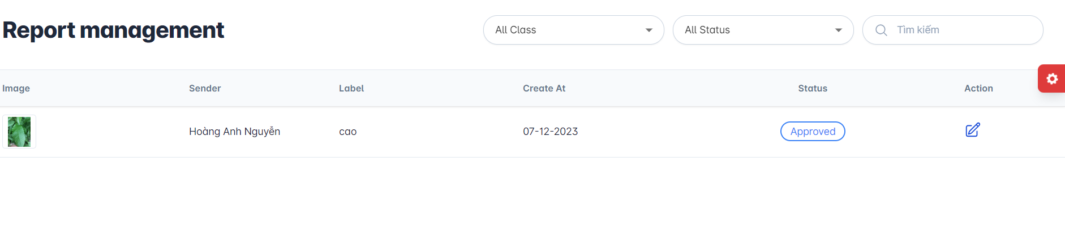

### **3.8.2 Manager model**

Step 1: View all class report manager created

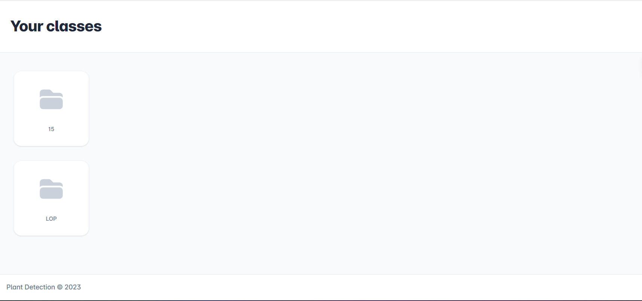

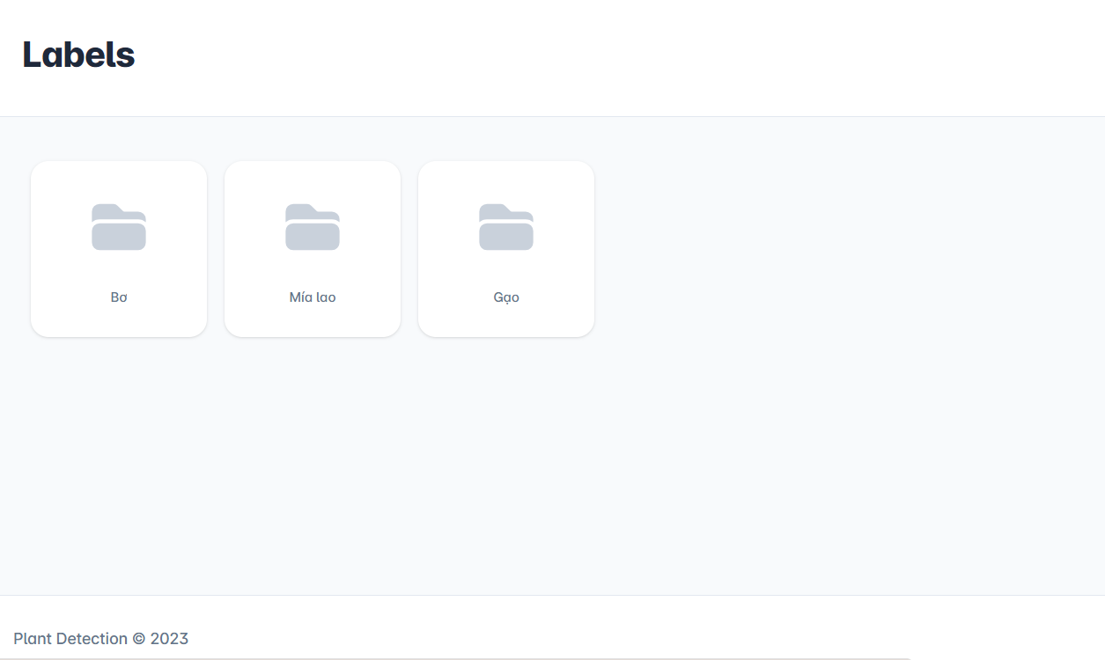

Step 2: See all images user reports

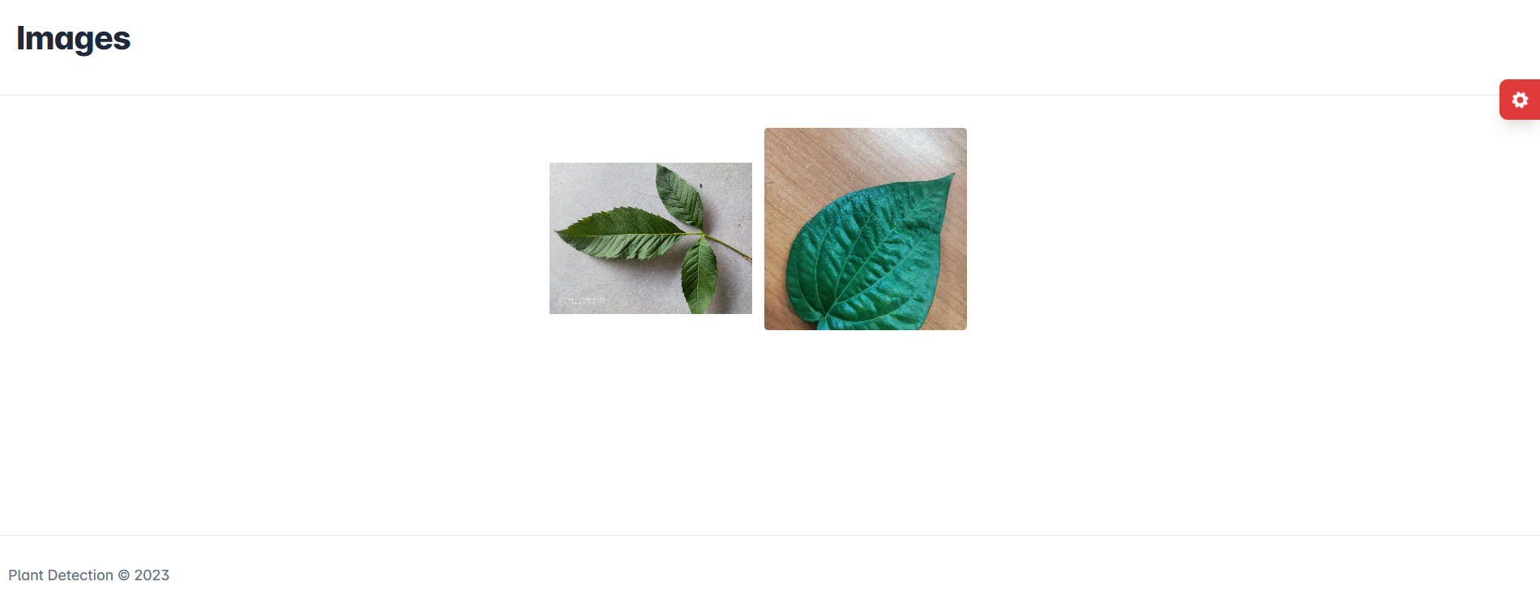

Choose picture and update new model for user